UKS2 Sum 1 Cycle A    Animals inc humans  Reproduction | To be secure in this unit you must:  - describe the differences in the life cycles of a mammal, an amphibian, an insect and a bird  - describe the life process of reproduction in some plants and animals.  - describe the changes as humans develop to old age. |  | Develop scientific skills:  - taking measurements, using a range of scientific equipment, with increasing accuracy and precision, taking repeat readings when appropriate  - recording data and results of increasing complexity using scientific diagrams and labels, classification keys, tables, scatter graphs, bar and line graphs  - using test results to make predictions to set up further comparative and fair tests  - Identifying scientific evidence that has been used to support or refute ideas or arguments.
Vocabulary |  | Sticky Knowledge |  | Useful Diagrams
 |  | Development of the foetus  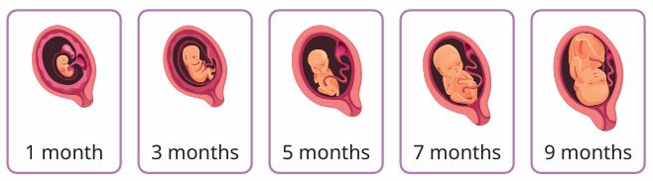  Human development to old age  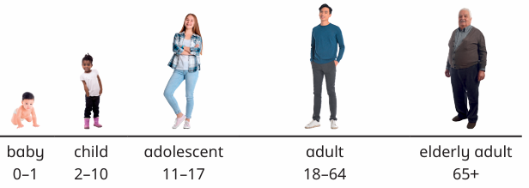  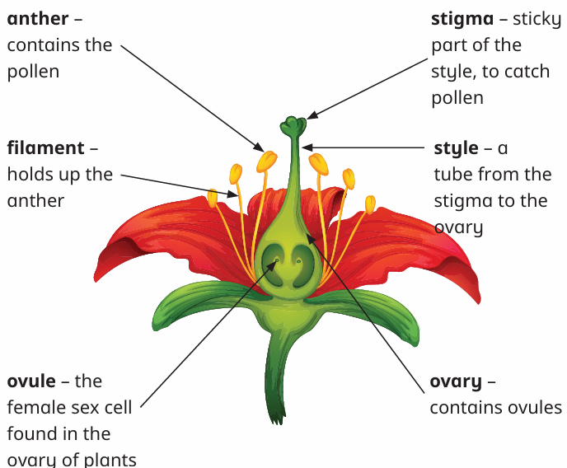 |  | Asexual reproduction in plants  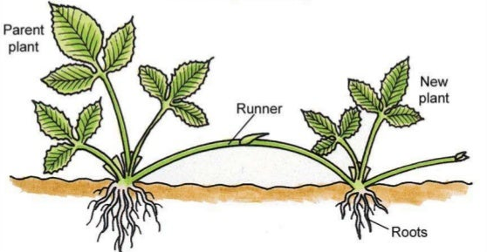  Sexual reproduction in plants through pollination  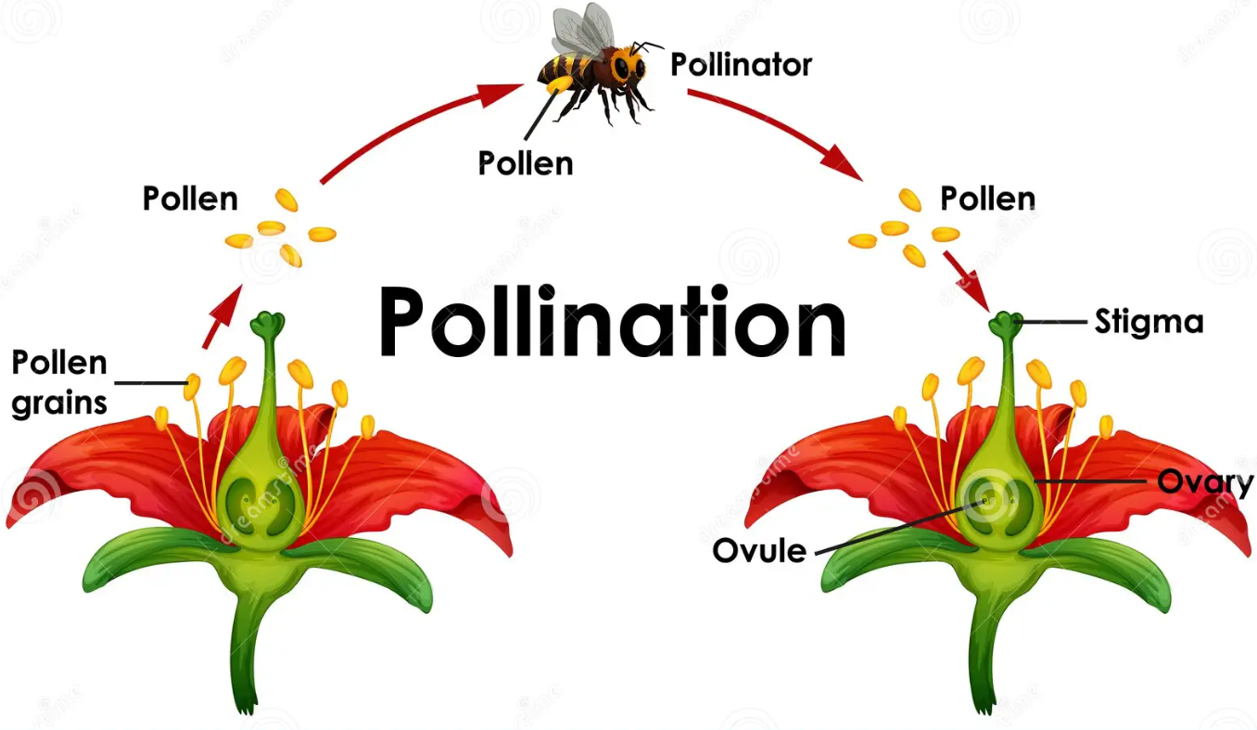
  fertilisation | the joining of a male and female sex cell to create a new life
  gestation | the period of time that a foetus develops in its mother’s womb
  embryo | the earliest stage of development after fertilisation
  foetus | an unborn baby growing inside the mother’s womb
  sperm cells | the male sex cells that are produced in the testes
  egg cells | the female sex cells that develop in the ovaries
  sexual reproduction | a process of making non-identical offspring which requires two parents
  asexual reproduction | the production of identical offspring from only one parent
  stamen | the male parts of the flowering plant (anther and filament)
  anther | contains the pollen
  filament | holds up the anther
  pistil | the female part of the flowering plant (stigma, style and ovary)
  stigma | sticky part of the style to catch the pollen
  style | a tube from the stigma to the ovary
  ovary | contains the ovules
  ovule | the female sex cell found in the ovary of the plants
  clone | a plant or animal that was produced asexually and is identical to its parent
  parent plant | the plant from which offspring are grown
  useful vocabulary: baby, toddler, child, adolescent, adult, elderly adult, life expectancy, runner, tuber, cutting, pollination,

