  UKS2 Sum 1 3D Art | To be secure in this unit you must:  Take Inspiration from the Greats:  - - Research the work of an artist and replicate their style.  - Understand that art can be abstract and interpret what the meaning could be.  - Explain the style of art used and how it has been influenced by a famous artist.  Evaluate & Develop your work:  - - Compare techniques and ideas or themes in their own work and that of others and explain what they think or feel about it.  - Annotate work to record ideas and emotions using this to inform design ideas and thumbnail drawings/designs. |  | Develop 3D art skills:  - Show life-like qualities and real-life  proportions or, if more abstract, provoke different interpretations.  - Use tools to carve and add shapes, texture and pattern.  - Combine visual and tactile qualities.  Use frameworks (such as wire or moulds) to provide stability and form.  Develop painting skills:  - Combine colours, tones and tints to enhance the mood of a piece.  Develop drawing skills:  - Create accurate drawing including proportion  - Experiment with marks and lines to create texture
Vocabulary |  | Sticky Knowledge |  | Inspiration
 |  | 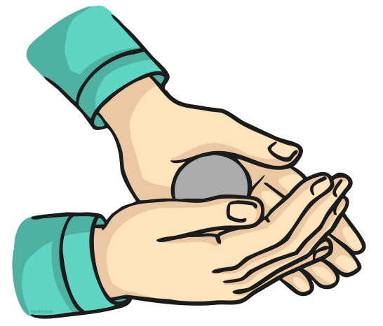  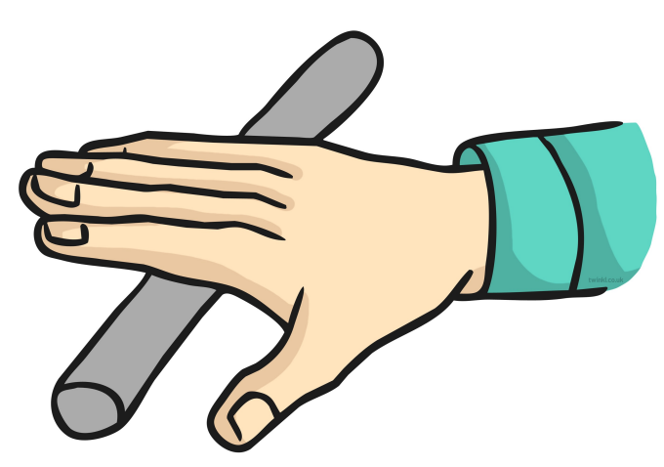  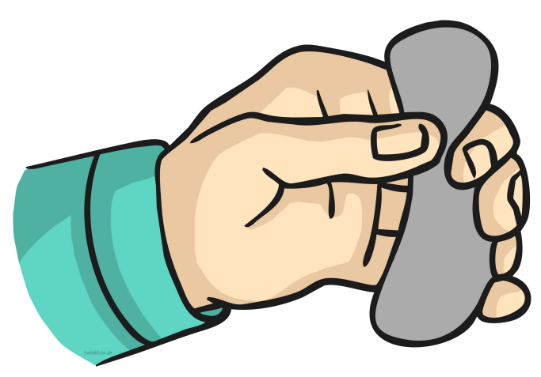  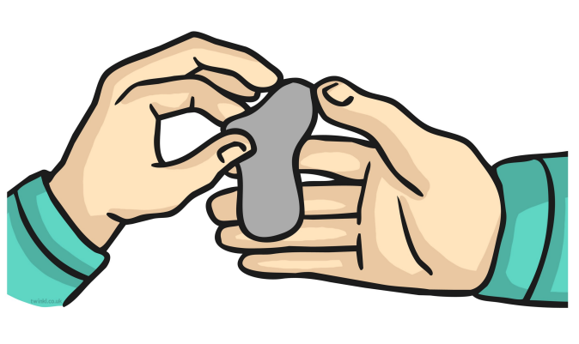  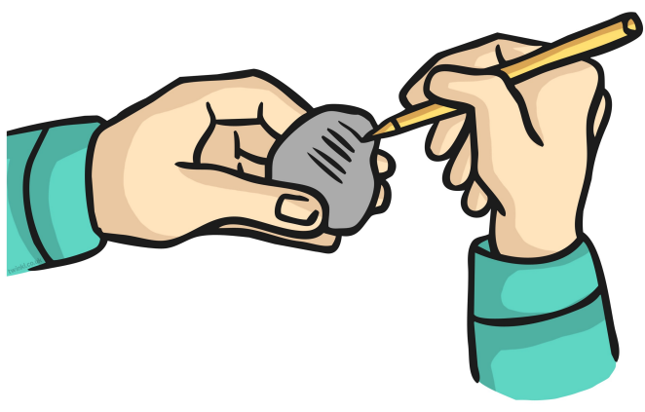  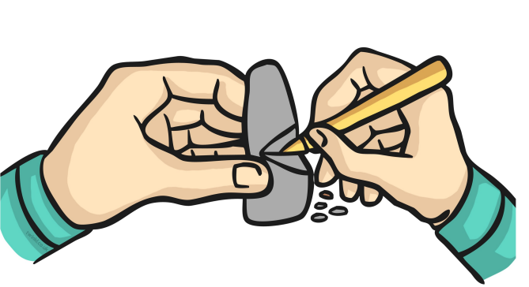  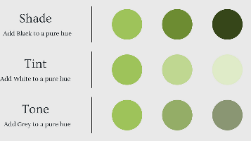  Rolling a ball  Rolling snakes  Squeezing  Pulling and pinching  Carving details  Making holes or hollows  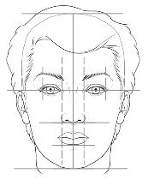  Key Experiences  Investigate the works of Yayoi Kusama and express an opinion about her work.  Experiment with the use of wire to create a stem inspired by Kusama’s ‘Flowers that bloom..’ series.  Use Modroc to strengthen the stem in preparation for supporting the flower head.  Use knowledge of tints, tones and shades to paint the stem.  Manipulate coloured clay into shapes to create a flower head inspired by Yayoi Kusama.  Draw your creation paying attention to accurate proportions.  Evaluate the work of a friend and your own to help think like an artist and suggest next steps. |  | Yayoi Kusama  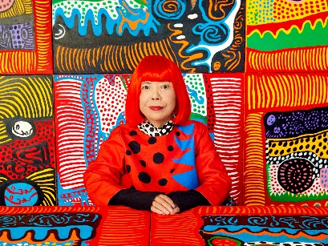  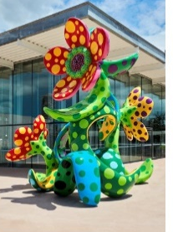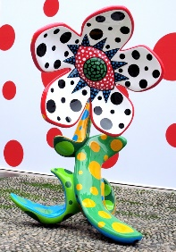  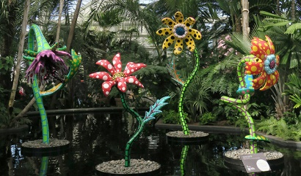
  Medium/media | The material/s that an artwork is made from
  Form | A 3D object, it has height, width, and depth
  Abstract | Artwork that doesn’t attempt to appear true to life
  pattern | A design that is repeated
  space | The area around, above and within an object
  Avant-garde | Any artist, artwork or movement that pushes boundaries
  Stability | Being secure, not likely to give way or overturn.
  Contrast | Arranging opposite elements e.g. light and dark, rough and smooth
  Texture | How something feels or looks like it feels
  Malleable | Material that is easy to manipulate
  Sculpt | To form, shape and manipulate material
  Carve | Using to tools to cut into an object
  proportion | The relationship between the height, width, and depth.

