  UKS2 Sum1 A  Anglo Saxons & Scots | To be secure in this unit you must:  - Begin to know how Britain changed between the end of the Roman occupation and 1066. (Continued in next unit: Anglo-Saxons and Vikings)  - Know that during the Anglo-Saxon period, Britain was divided into many kingdoms and that these lead to some of our county boundaries today.  -Explain the Roman withdrawal from Britain in c. AD 410 and the fall of the Western Roman Empire.  -know when the Anglo-Saxons and Scots settled in Britain and how that happened.  -know about the main achievements of the Anglo-Saxons and Scots.  -To identify the continuities and changes between Roman and Anglo-Saxon society and housing.  -know about the link between Anglo-Saxons and Christianity.  -Know about the famous Anglo-Saxon site: Sutton Hoo. |  | Develop historical skills:  - Use sources of evidence to deduce information about the past.  - Show an awareness of how historians must understand the social context of evidence studied including bias.  - Describe the main changes in a period of history using historical terms such as: society, settlement.  -Use dates and terms accurately in describing events.  - Describe the social, ethnic, cultural or religious diversity of past society.  -Describe the characteristic features of the past, including ideas, beliefs, attitudes and experiences of men, women and children.  Use appropriate historical vocabulary to communicate, including: dates, time period, era, chronology, continuity, change, century, decade, legacy.
Vocabulary |  | Sticky Knowledge |  | Topic Timeline
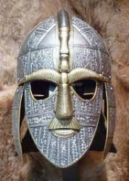  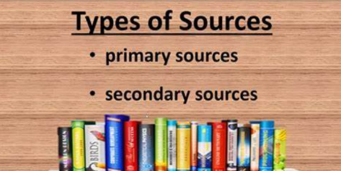  Primary Sources  Secondary Sources  Interpretative Sources |  | - The Anglo-Saxons were made up of three tribes: the Angles; Saxons; and Jutes.  - The name ‘Angles’ eventually became ‘English’ and their land, ‘Angle-land’, became ‘England’.  - They came to Britain from across the North Sea in the middle of the 5th Century.  - For a long time, England was not one country. Anglo-Saxon kings ruled lots of small kingdoms across the land.  - The Anglo-Saxons were fierce people who fought many battles, including fighting each other.  - By AD 600, they had created seven kingdoms across Britain.  - Sometimes, the period after the Romans left is called ‘The Dark Ages’. Anglo-Saxons returned to simpler houses, lost trade and education. However, there some significant changes during Anglo-Saxon rule: Move to Christianity, women had more opportunities, eventually history was written down.  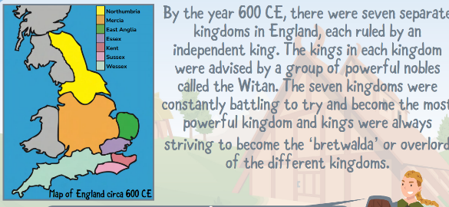
  Settlement | People who live in an area for a sustained period of time and form a community.
  Anglo-Saxon Kingdom | The Anglo-Saxons formed many regions each with one ruler, known as kingdoms.
  Shires | Saxon lands were divided into shires, which helped to make up the counties we have today.
  Conquer | To overcome and take control of people or land using military force.
  Invade | Enter a place or land with the intention of occupying it.
  Empire | An empire imposes its rule on peoples of different cultures and ethnic backgrounds with different political systems and controls lands beyond the borders of its own country.
  Bias | Prejudice for or against a person, group or idea that is based on personal opinion rather than objective facts.
  55 BC | Julius Caesar attempt to invade Britain for the 1st time.
  54 BC | Julius Caesar attempts to invade Britain for the 2nd time.
  AD 43 | Romans invade and take over Britain under Emperor Claudius
  AD 410 | Last Roman troops withdraw from Britain
  AD 476 | Roman Empire came to an end (Western)
  c. AD 450 | Anglo-Saxons started to settle and then spread over England and Wales, creating Kingdoms.
  By AD 600 | Seven Kingdoms are created across Britain.
  AD 793 | First recorded Viking raid at Lindisfarne
  AD 843 | Union of Pics and Scots under Kenneth I MacAlpin across much of southern and central Scotland.
  c. AD 865 | Vikings invaded in the North.
  1939 | Discovery of Anglo-Saxon burial site – Sutton Hoo
  See the next Knowledge Organiser for key dates of the Anglo-Saxon and Viking struggle for Britain.

