UKS2 Aut 1 B    Painting | To be secure in this unit you must:  Take Inspiration from the Greats:  • Research the work of an artist and replicate their style.  •Understand what an artist is trying to achieve through their work.  •Explain the style of art used and how it has been influenced by a famous artist.  Evaluate & Develop your work:  • Make changes to work after evaluation and give suggestions for further development. |  | Develop painting skills:  - Sketch (lightly) before painting to combine line and colour.  - Use the qualities of watercolour and acrylic paints to create visually interesting pieces.  - Combine colours, tones and tints to enhance the mood of a piece.  - Create different effects using a variety of tools and techniques e.g. dots, scratches and splashes, and applying paint in layers.  - Demonstrate a secure knowledge about primary and secondary, warm and cold, complementary and contrasting colours.  - Choose appropriate paint, paper and implements to adapt and extend their work.
Vocabulary |  | Sticky Knowledge |  | Inspiration
 |  | - Van Gogh pioneered the use of the impasto technique.  - Van Gogh used warm and cold colours to create emotions within his paining.  - Van Gogh was part of the post-impressionist movement  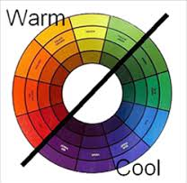  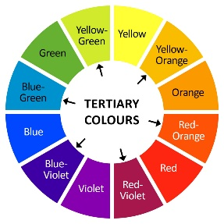  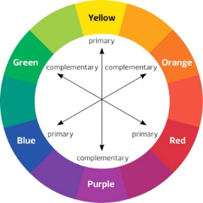  Key Experiences  - Learn a little about key periods in Western Art inspired by Framed, considering famous artists they have encountered during their time at Summerseat.  - Give opinions on artwork used in the book, Framed’.  - Create warm, cool and complementary colour pieces to help them remember these terms.  - Inspired by Van Gogh, explore his watercolour pieces and create a landscape watercolour inspired by our Summerseat surroundings.  - Create artwork using acrylic paint to work in Van Gogh’s impasto style inspired by Starry Night but with personal meaning. |  | 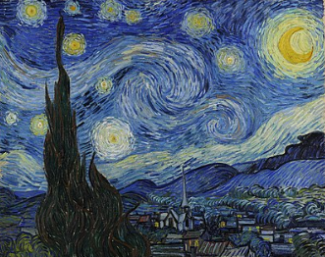  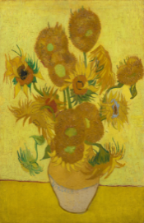  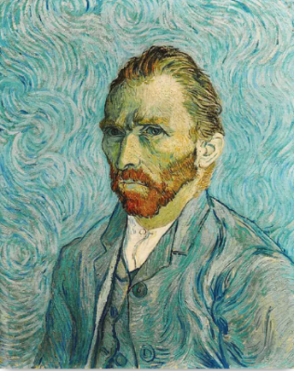  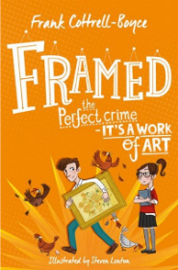
  Impressionism | Style of painting focused on modern life from 1865. Impressionist artists were not trying to paint a reflection of real life, but an 'impression' of what the person, object or landscape looked like to them.
  Post-Impressionism | A group of painters that followed impressionists with a unique style and work that had personal meaning.
  Impasto | Painting technique where paint is applied in thick layers, usually thick enough that the brush or painting knife strokes are visible.
  Acrylic paint | Art medium which can be thickened like oil paint or diluted like watercolour.
  Watercolour | Art medium or style with lots of water and little pigment.
  Tertiary colours | Colours made by mixing a primary and secondary colour together.
  Texture | The way a painting feels or looks
  Complementary colours | Colours that are directly opposite each other on the colour wheel.
  Warm colour | Warm colours are considered red, yellow and orange. These are colours associated with heat and the emotions excitement, anger and frustration.
  Cold colour | Cool colours are blue, green and violet. The cool colours are associated with cold things, like ice, and feelings such as sadness, comfort and calm.

