

Summerseat Methodist Primary
Steps in Learning, Skills for Life

Expectations for Key Stage Two
Year Five, Cycle B

What knowledge and skills will you gain on your learning journey this year?

Summerseat Methodist Primary School’s Steps in Learning
This booklet provides an overview of the topics taught in the year group for all the subjects and also outlines the end of year exceptions for children in our school for maths and English. It also contains the knowledge organisers for maths and English which we use with the children in school. Science, geography and history knowledge organisers for the first half of the autumn term are also included for information and subsequent terms will come home at the start of each topic to let you know the key knowledge children will gain during the topic.
At the back of the booklet are our learning to learn skills which are taught progressively and explicitly in all year groups to ensure our pupils leave the school as ‘well rounded’ individuals. It also contains our ‘Infinite Eight’ enrichment offer for the year.
This is a ‘snapshot’ of our curriculum and more information on skills progression for each curriculum area can be found in our subject ‘Steps in Learning’ which are our key progression documents.
If you have any queries regarding the content of this booklet or want support in knowing how best to help your child please talk to your child’s class teacher.
Please find below an overview of the topics that your child will cover this year in Year Five:
Ash Class Topics – Cycle B
Autumn 1 | Britain’s National Parks  The Seven Wonders of the World
Autumn 2 | Britain’s National Parks  The Seven Wonders of the World
Spring 1 | World War II
Spring 2 | World War II
Summer 1 | North America
Summer 2 | Local History of Manchester

The school vision, motto and values have directed our curriculum intent and design and are interwoven within in.
“I have come so that they may have life and have it to the full.” John 10:10
Believe. Achieve. Shine.

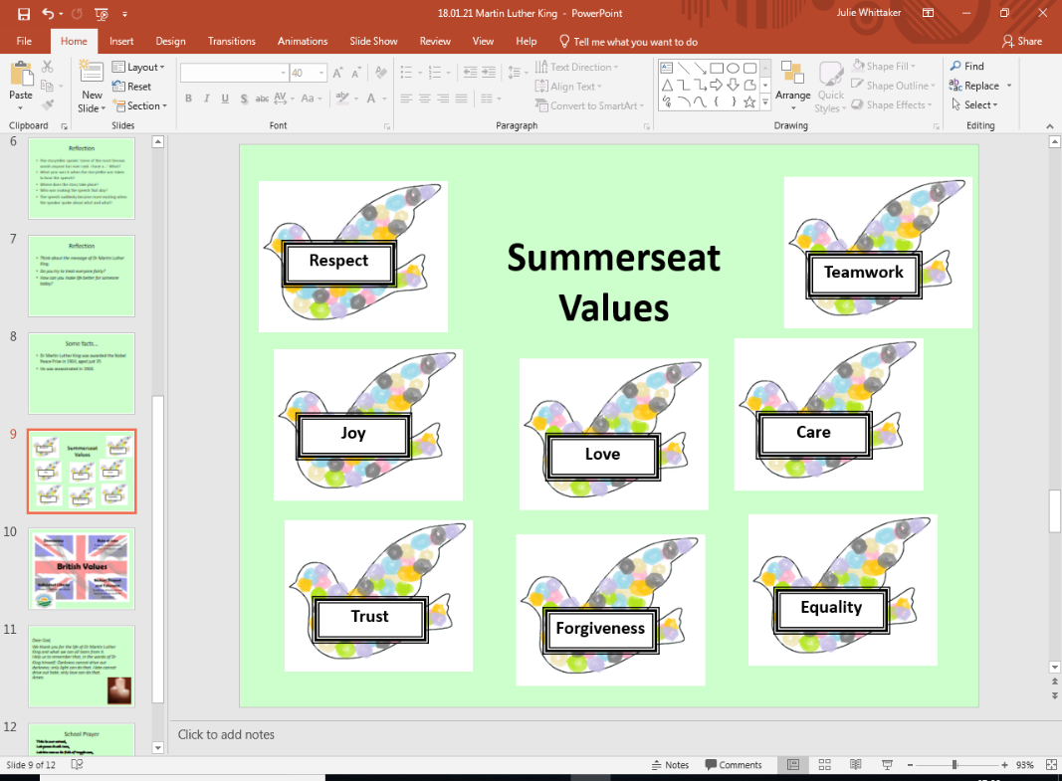
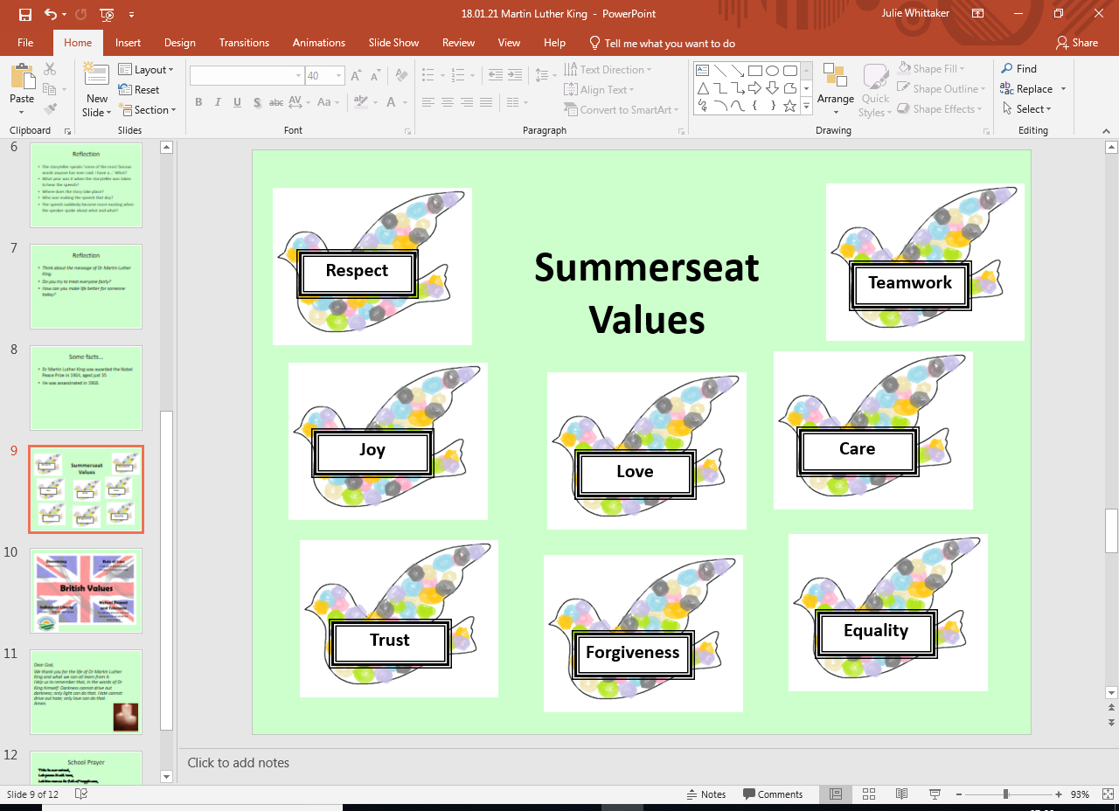

Summerseat Methodist Primary School – 2026-27 Long Term Plan – Cycle B

Autumn Term |  |  |  | Spring Term |  |  |  | Summer Term
English - Writing
Core Text: |  | Core Text: |  | Core Text: |  | Core Text: |  | Core Text: | Core Text:
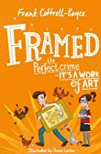 |  | 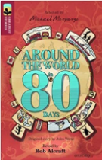 |  | 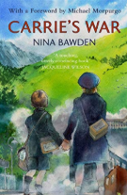 |  | 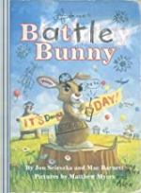 |  | 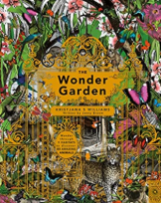 | 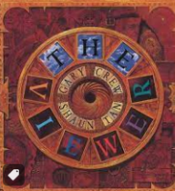
Framed  Frank Cottrell-Boyce |  | Around the World in 80 Days  Treetops –Original by Jules Verne |  | Carrie’s War  Nina Bawden |  | Battle Bunny -  Jon Scieszka, Mac Barnett, Matthew Myers |  | The Wonder Garden - Broom | The Viewer - Crew
Additional Text:  Sandy Cove (short story)  Bedgellert |  | Additional Text:  Elves and Sprites |  | Additional Text: |  | Additional Text: |  | Additional Text:  Pandora – film (gardens and oceans) | Additional Text:  Children’s history of Manchester
Poetry
An English Holiday – Rumble * | War Poetry (At C’mas look at Truce) http://www.keystage2literacy.co.uk/world-war-poetry.html |  |  |  |  |  | The Jaberwocky – Carroll (Nonsense) | The Lady of Shallot – Tennyson (Poet Laureate) |  |  | The Bees Still Buzz –  Ryan Williams *
Reading
Reading Comprehension |  | Reading Comprehension |  | Reading Comprehension |  | Reading Comprehension |  | Reading Comprehension | Reading Comprehension
Fiction |  | Fiction |  | Fiction |  | Fiction |  | Fiction | Fiction
 |  |  |  |  |  | 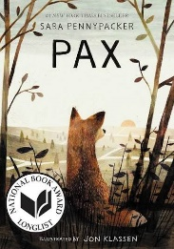 |  | 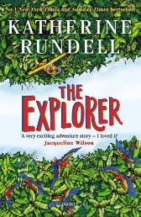 | 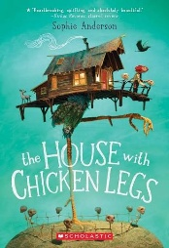
Framed  Frank Cottrell-Boyce |  | Around the World in 80 Days |  | Carrie’s War  Nina Bawden |  | Pax  Jon Klassen |  | The Explorer  Katherine Rundell | The House With Chicken Legs  Sophie Anderson
Non-Fiction |  | Non-Fiction |  | Non-Fiction |  | Non-Fiction |  | Non-Fiction | Non-Fiction
Complete Comprehension – Harry Houdini |  | Complete Comprehension – Hidden Figures |  | WW2 Letters and Poems Book |  | Complete Comprehension – Marius The Giraffe Killed at Copenhagen Zoo  Sea Wold decided to Stope Killer Whale Breeding Program – The Guardian
Poetry |  | Poetry |  | Poetry |  | Poetry |  | Poetry | Poetry
 |  | Complete Comprehension – For the Fallen |  |  |  |  |  |  | This is The Place – Tony Walsh
Handwriting
Mathematics
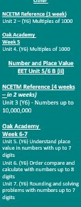  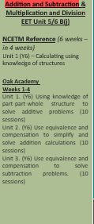
  Number & Place Value, Number Facts, Other
  NCETM Reference (5 weeks – revision unit – 3 weeks)
  Unit 1 (Y5)- Decimal Fractions
  Oak Academy
  Week 1-3
  Unit 1. (Y5) Understand tenths as parts of a whole, represent and calculate mentally
  Unit 2. (Y5) Compose and calculate with decimals including column addition and subtraction
  Unit 3. (Y5) Understand hundredths as part of a whole and represent
  Unit 4. (Y5) Use knowledge of decimals to solve problems in different contexts: length
  Use LBQ to relate to percentage equivalence
  Number & Place Value & Fractions
  EET Unit 5/6 B (iii)
  NCETM Reference (7 weeks in 2 week review)
  Unit 8 (Y5) - Fractions
  Oak Academy
  Unit 18 (Y5) . Multiply a proper fraction by a whole number (5 sessions)
  Unit 19. (Y5) Multiply improper fractions and mixed numbers by a whole number (5 sessions)
  Unit 20.(Y5) Find unit and non-unit fractions of whole numbers exploring parts and wholes (10 sessions)
  Unit 21. (Y5) Comparing fractions using equivalence and decimals (10 sessions)
  Addition and Subtraction, Multiplication and Division & Other
  NCETM Reference (4 weeks – 2 weeks before the holiday, 2 weeks after
  Unit 5 (Y6) - Multiplication and Division
  Oak Academy
  Week 6
  Unit 9 (Y6) Using Equivalence to Calculate
  Week 7
  Unit 10. (Y6) Multiplying and dividing by 2-digit numbers
  Addition and Subtraction, Multiplication and Division & Other
  NCETM Reference (4 weeks – 2 weeks before the holiday, 2 weeks after
  Unit 5 (Y6) - Multiplication and Division
  Oak Academy
  Week 1-2
  Unit 10. (Y6) Multiplying and dividing by 2-digit numbers
  Other
  NCETM Reference
  Unit 6 (Y6) - Area, Perimeter, position and direction
  Oak Academy
  Week 3-4
  Unit 11 (Y6) . Area, Perimeter, position and direction
  Fractions & Other
  NCETM Reference (6 weeks – 2 before the holiday, 4 after)
  Unit 7 (Y6) - Fractions and Percentages
  Oak Academy
  Week 5-6
  Unit 12 (Y6) Addition and Subtraction of Fractions
  Fractions & Other
  NCETM Reference (6 weeks – 2 before the holiday, 3 after)
  Unit 7 (Y6) - Fractions and Percentages
  Oak Academy
  Week 1
  Unit 13. (Y6) Comparing fractions
  Week 2
  Unit 14. (Y6) Multiplication and division of fractions
  Week 3-4
  15. (Y6) Understanding percentages
  Other
  NCETM Reference (1 week)
  Unit 8 (Y6) - Statistics
  Oak Academy
  Week 5
  Unit 16. (Y6) Statistics
  Addition and Subtraction & Multiplication & Division
  NCETM Reference (2 weeks – 1 before holiday, 1 week after)
  Unit 9 (Y6) - Ratio and Proportion
  Oak Academy
  Week 6
  Unit 17. (Y6) Ratio and proportion (Part 1)
  Addition and Subtraction & Multiplication & Division
  NCETM Reference (2 weeks – 1 before holiday, 1 week after)
  Unit 9 (Y6) - Ratio and Proportion
  Oak Academy
  Week 6
  Unit 17. (Y6) Ratio and proportion (Part 2)
  SATS REVISION
  Week 2-3
  SATS
  Week 4
  Other
  NCETM Reference (1 week)
  Unit 13 (Y6) – Mean Average
  Oak Academy
  Week 5
  Unit 21 (Y6) Mean Average
  Week 6
  Consolidation
  Geometry
  NCETM Reference (2 weeks)
  Unit 4 (Y6) - Draw, compose and decompose shapes
  Oak Academy
  Week 1-2
  Unit 8. (Y6) Draw, compose and decompose shapes
  Addition and Subtraction & Multiplication & Division
  NCETM Reference (1 week)
  Unit 10 (Y6) – Calculating using knowledge of structures (2)
  Oak Academy
  Week 3
  Unit 18. (Y6) Calculating using knowledge of equivalence in addition and subtraction
  Addition and Subtraction & Multiplication and Division
  NCETM Reference (2 weeks)
  Unit 11 (Y6) Solving problems with two unknowns
  Week 4-5
  Oak Academy
  Unit 19. (Y6) Solving problems with two unknowns
  Week 6
  Consolidation
Science
Biology  Evolution & Inheritance (variation, adaptation, fossils) |  | Physics -Space  Sustainability - Global Warming |  | Biology  The Circulatory system | Biology  Diet, Drugs and Lifestyle |  |  | Physics - Electricity  Sustainability - Renewable energy |  | Biology  Living things and their habitat
RE
Why do Hindus want to be good? |  |  |  | 2b.2CREATION/  FALL: Creation & Science – Conflict or Complimentary? |  | 2b.6 SALVATION: What did Jesus do to save Human Beings? Easter OR 2b.7: SALVATION:  What difference does the resur-rection make to Christians? Easter |  | 2b.8 KINGDOM OF GOD: What kind of King is Jesus? OR 2b.3 PEOPLE OF GOD: How can following God bring freedom and Justice? | How does faith help people when life gets hard?
History
 |  |  |  | A study of an aspect or theme in British history that extends understanding beyond 1066  World War II - Battle of Britain |  |  |  |  |  | Local History of Manchester  (History including local study and Geography)
Geography
Britain’s National Parks |  |  | The Seven Wonders of the World  (Geographical Concepts) |  |  |  |  | North America
Art
Painting  Vincent van Gogh -Flowers |  |  |  |  | Digital Art / Drawing  Renoir - Umbrellas |  |  |  |  | Drawing / Painting  Banksy  Buildings (perspective) / Banksy
DT
 |  |  | Electrical Systems  More complex circuits & switches  Moon Buggy to carry a passenger | Textiles  Combining skills and materials  Mobile Phone pouch  Designer: Vivienne Westwood |  |  |  | Food  Celebrating culture  Road Trip USA  Making burgers & pie
PE
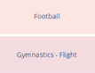 |  |  |  | 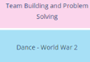 |  | 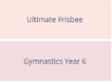 |  |  | 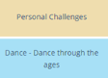
PSHE
Knowing Me, Knowing You |  | Relationships and the Wider World |  | Keeping Healthy |  | Keeping Safe (Inc. CWP Preventing Early Use) |  | Friends, Family & SRE | Friends, Family & SRE
 |  | Tango Makes Three – Justin Richardson and Peter Parnell |  | Rose Balnche – Ian McEwan and Roberto Innocenti |  | Where Poppies Grow – Hilary Robinson and Martin Impey |  | The Artist Who Painted A Horse Blue – Eric Carle | How To Heal a Broken Wing- Bob Graham
One lesson every half term has an Anti-Bullying and No Outsiders focus.
Computing
6-Networks  4 weeks  5-Databases  4 weeks |  | 6-Blogging  6 weeks |  | 5-Concept maps  4 weeks  6-Introduction to Python  4 weeks |  | Coding  6 weeks |  | 5-Spreadsheets  6 weeks | 6-Data detectives  4 weeks
Online Safety – Delivered throughout the year using Evolve Resources

French
Actions |  | In France |  | Jobs |  | The Environment |  | Family | A Weekend With Friends
Music
The Fresh Prince of Bel Air |  | Songs For Christmas |  | Western Classic to  1940: 20th Century:  Holst ‘Mars from the  Planets’  Western Tradition &  Film post 1940:  Zimmer - Earth |  | Glokenspiel Stage  2, then song book.  / Key board  beginner |  | Glockenspiel /  Key board | Oasis vs The  Beatles
Visits and Visitors / Hook
 |  | Jodrell Bank |  | Fusilier Museum |  |  |  |  | Anderton Centre Day Visit

Writing
Oracy for Writing
Performs own writing confidently to an audience, using intonation, volume and pace.
Discusses own and others’ writing critically, considering audience impact.
Uses appropriate registers for effective communication.

Composition: Sentences
Chooses sentence structures deliberately for effect.
Maintains tense accurately across extended texts.
Uses cohesion devices (pronouns, repetition, adverbials) within paragraphs.
Varies sentence length and structure to influence the reader.

Punctuation
Uses all taught KS2 punctuation accurately. (. ! ? , ‘ “” - ())
Uses commas to clarify meaning or avoid ambiguity.

Composition: Context, Audience, Purpose
Writes texts with clear audience and purpose.
Maintains viewpoint and detail to engage the reader consistently.
Uses modal verbs appropriately to indicate possibility, probability, necessity or obligation in their writing

Composition: Narrative
Writes complete narratives with clear structure and pacing.
Creates engaging openings and atmosphere in characterisation and settings.
Links paragraphs clearly to develop the plot.

Composition: Non-narrative
Writes non-narrative texts with clear introduction, organised points and logical conclusion.
Uses organisational and presentational devices confidently.
Summarises longer passages with growing independence.

Composition: Editing
Edits grammar and vocabulary for impact.
Improves writing to meet the task brief.
Evaluates own and others’ writing with specific suggestions.

Spelling
Spells KS1 and KS2 words accurately.
Distinguishes homophones and commonly confused words.
Spells some words with silent letters.
Uses dictionaries and thesauri effectively.
Applies knowledge of word morphology and etymology.

Reading
Oracy & Reading
Discusses a wide range of texts, giving explanations, opinions and comparisons.
Asks and answers questions to clarify and deepen understanding.
Reads aloud fluently with expression and varied intonation.
Retells myths, legends and traditional tales in different forms.
Performs poems and playscripts with tone, volume, and movement.
Explores vocabulary and phrases that capture the reader’s imagination.
Word Reading & Decoding
Reads longer, more complex texts fluently.
Understands meaning of unfamiliar words using prefixes, suffixes and word roots.
Language in Context: V
Checks comprehension and self-corrects when needed.
Uses knowledge, context and dictionaries to define unfamiliar words.
Collects ambitious vocabulary from reading to apply in writing.
Comprehension – Retrieval: R
Skims and scans to locate precise information.
Answers a range of comprehension questions, citing evidence.
Reads silently and discusses interpretation confidently.
Comprehension – Sequencing & Summarising: S
Organises events or ideas across chapters or whole texts.
Summarises key points and themes succinctly.
Explains relationships between ideas across longer texts.
Comprehension – Inference: I / P
Draws inferences about characters’ feelings, motives and viewpoints.
Explains how authors use evidence to shape readers’ responses.
Justifies inferences with well-chosen references.
Makes predictions based on evidence, author style or themes.
Comprehension – Choice of Language: WP
Analyses how vocabulary and figurative language shape meaning.
Explains how sentence structure creates effects such as tension or pace.
Evaluates author choices for atmosphere, characterisation and impact.
Comprehension – Themes & Conventions: E / C
Identifies and compares text types and features.
Uses non-fiction layout effectively to locate and summarise information.
Recognises recurring themes, cultural and historical influences.
Explores differences in style between authors and genres.
Identifies and discusses a range of poetic forms.
Evaluates texts, commenting on effectiveness and author’s craft.


A Year Five Child
English

Speaking
• Engage the interest of the listener by varying their expression and vocabulary
• Adapt spoken language to the audience, purpose and context
• Explain the effect of using different language for different purposes
• Develop ideas and opinions with relevant detail
• Express ideas and opinions, justifying a point of view
• Show understanding of the main points, significant details and implied meanings in a discussion
• Listen carefully in discussions, make contributions and ask questions that are responsive to others’ ideas and views
• Begin to use Standard English in formal situations
• Begin to use hypothetical language to consider more than one possible outcome or solution
• Perform own compositions, using appropriate intonation and volume o that meaning is clear
• Perform poems or plays from memory, making careful choices about how they convey ideas about characters and situations by adapting expression and tone
• Understand and begin to select the appropriate register according to the context
Handwriting

• I can write legibly, fluently and with increasing speed.
• I can choose which shape of letter to use when given choices and deciding whether or not to join specific letters.
I can choose the writing implement that is best suited to a task. Adapts handwriting style for different audiences and purposes.
•

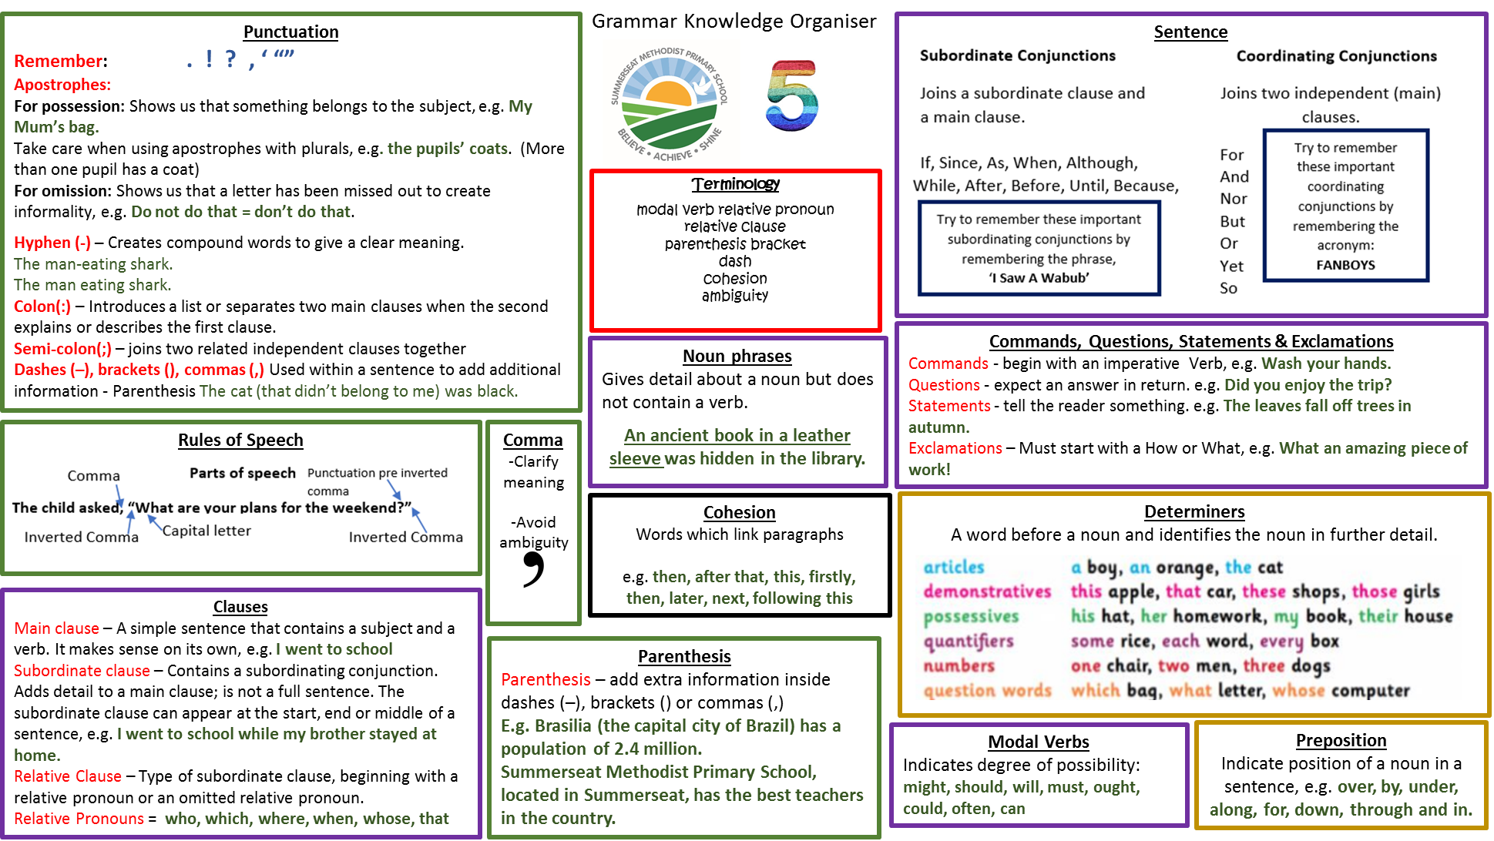

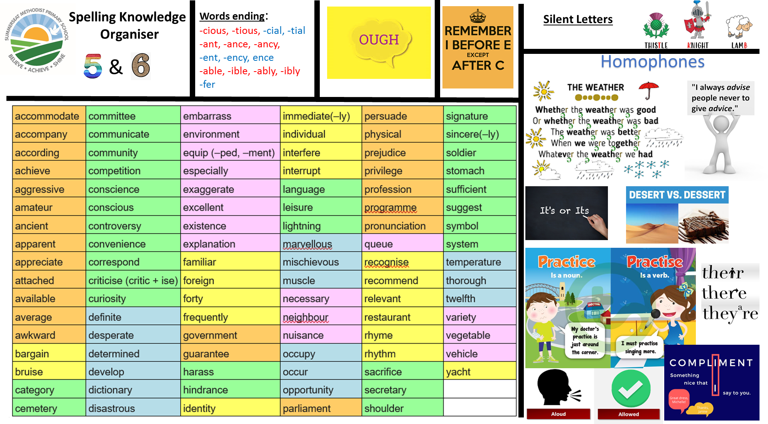


Being a Mathematician
Number
• Count forwards and backwards in steps of power 10 for any given number up to 1,000,000
• Read, write, order and compare numbers to at least 1,000,000 and determine the value of each digit
• Interpret negative numbers in context, count forwards and backwards with positive and negative whole numbers, including through zero
• Round any number to 1,000,000 to the nearest 10, 100, 1,000, 10,000 and 100,000. Round decimals with 2dp to the nearest whole number and to 1dp
• Recognise and use square numbers and cube numbers and the notation for squared (²) and cubed (³)
• Read Roman numerals to 1,000 (M) and recognise years written in Roman numerals
• Solve addition and subtraction multi-step problems in contexts, deciding which operations and methods to use and why; solve problems involving 3 decimal places
• Add and subtract numbers mentally with increasingly large numbers
• Use rounding to check answers to calculations and determine, in the context of a problem, levels of accuracy
• Add and subtract whole numbers with more than 4 digits, including using formal written methods (columnar addition and subtraction)
• Identify multiples and factors, including finding all factor pairs of a number, and common factors of two numbers
• Establish whether a number up to 100 is prime and recall prime numbers up to 19
• Multiply and divide numbers mentally drawing upon known facts up to 12 x 12
• Multiply and divide whole numbers by 10, 100 and 1,000
• Multiply and divide numbers involving decimals by 10, 100 and 1000
• Multiply number up to 4-digit by a 1 or 2-digit number using formal written methods, including long multiplication for 2-digit numbers
• Divide numbers up to 4-digits by 1-digit numbers
• Solve problems involving multiplication and division where large numbers are used by decomposing them into factors

Being a Mathematician
Fractions, Measurement, geometry & statistics

• Recognise mixed numbers and improper fractions and convert from one to the other
• Read and write decimal numbers as fractions, for example, 0.47 = 47/100. Recognise the per cent symbol (%) and understand per cent relates to number of parts per hundred
• Write percentages as a fraction with denominator hundred, and as a decimal fraction
• Compare and order fractions whose denominators are all multiples of the same number
• Identify, name and write equivalent fractions of a given fraction, represented visually, including tenths and hundredths
• Add and subtract fractions with the same denominator and denominators that are multiples of the same number
• Multiply proper fractions and mixed numbers by whole numbers, supported by materials and diagrams
• Recognise and use thousandths and relate them to tenths, hundredths and decimal equivalents
• Round decimals with two decimal places to the nearest whole number and to one decimal place
• Read, write, order and compare numbers with up to three decimal places
• Identify 3-D shapes, including cubes and other cuboids, from 2-D representations
• Know angles are measured in degrees: estimate and compare acute, obtuse and reflex angle
• Draw given angles, and measure them in degrees
• Identify angles at a point and one whole turn. Identify angles at a point on a straight line and ½ a turn. Identify other multiples of 90°.
• Use the properties of rectangles to deduce related facts and find missing lengths and angles
• Distinguish between regular and irregular polygons based on reasoning about equal sides and angles
• Convert between different units of metric measures and estimate volume and capacity
• Measure and calculate the perimeter of composite rectilinear shapes in centimetres and metres
• Calculate and compare the area of squares and rectangles including using standard units (cm² and m²)
• Estimate volume and capacity . Solve problems involving converting between units of time
• Identify, describe and represent the position of a shape following a reflection or translation, using the appropriate language, and know that the shape has not changed

A Year One Child
Mathematics

Addition Strategies

Subtraction Strategies

Multiplication Strategies

Division Strategies

For more detail on our mathematical strategies, please see our calculation policy and progression document.
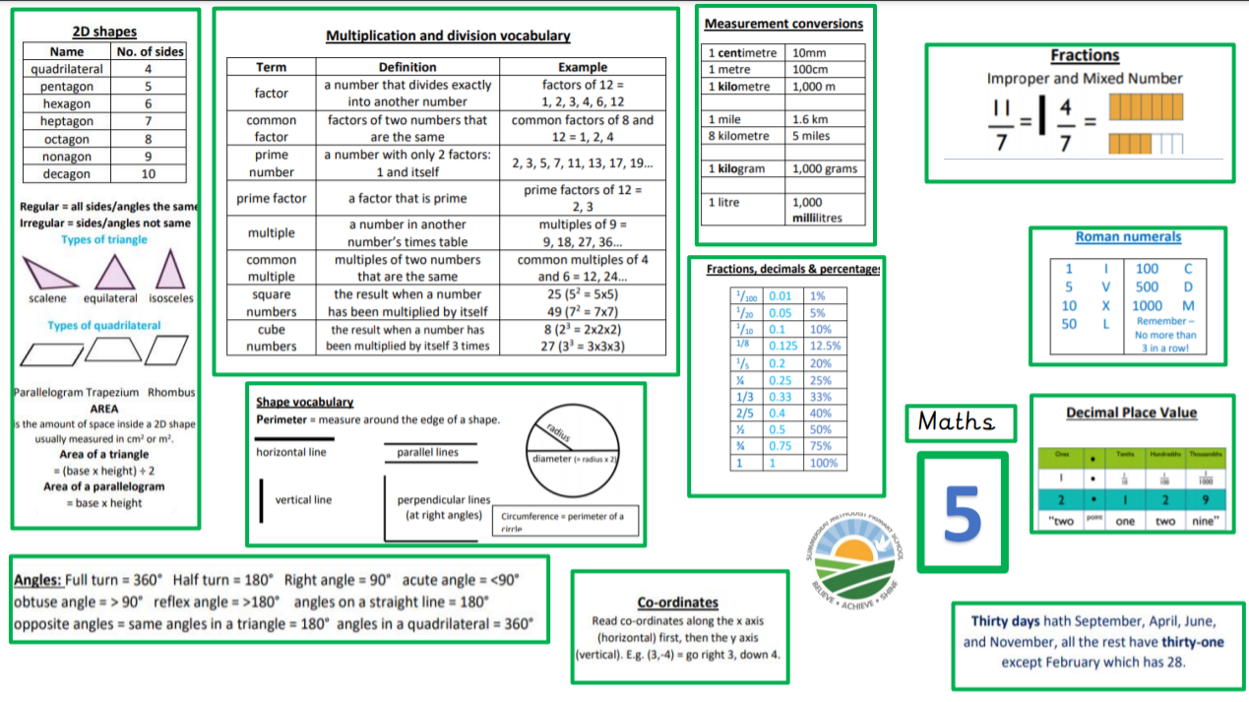

INSERT KOS for FIRST TERM

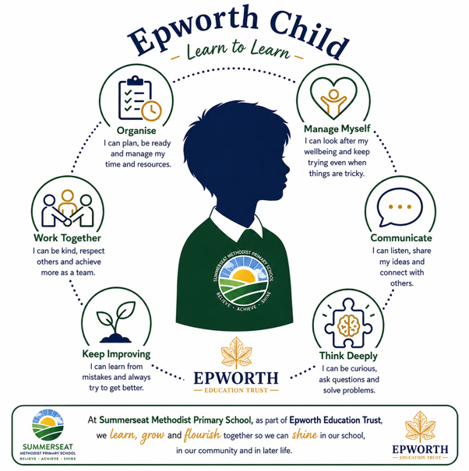
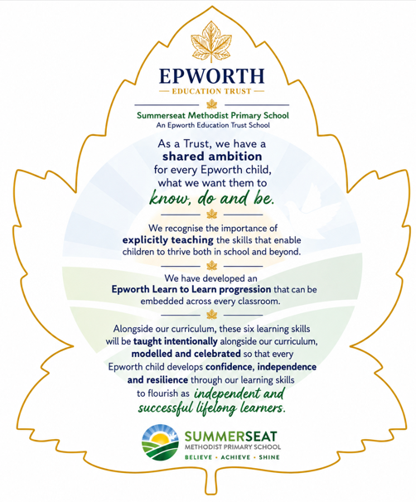
Learn to Learn Skills

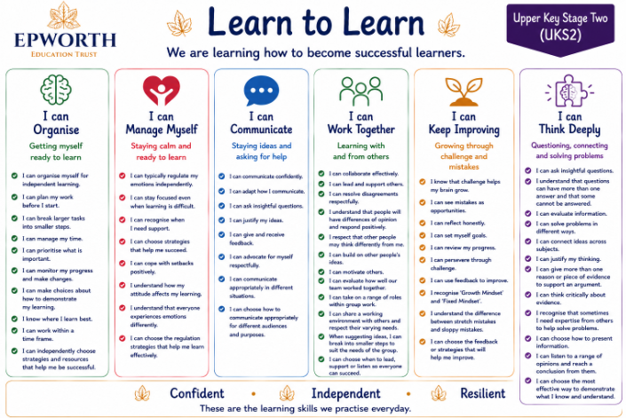
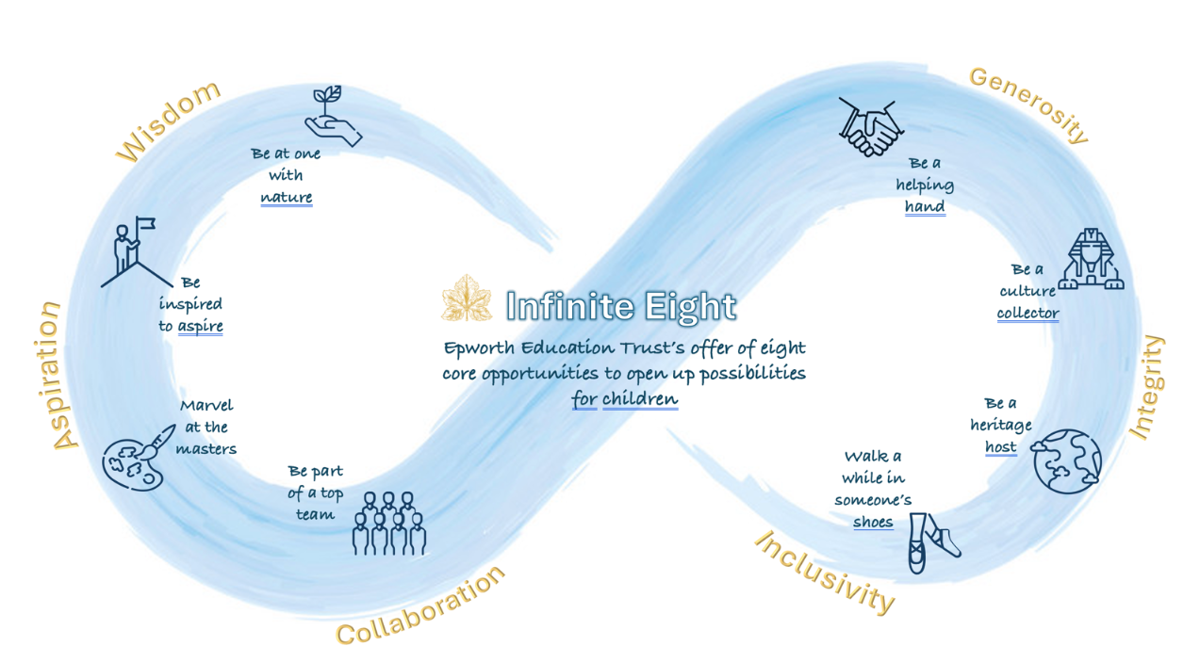
Be a culture collector
hjff

Be a heritage host

Walk a while in someone’s shoes

Be part of a top team

Marvel at the masters

Be inspired to aspire

Be a helping hand

Be at one with nature

Infinite Eight
Enrichment Offer
The ‘Infinite Eight’ strategy outlines Epworth’s offer of eight opportunities for children to enjoy meaningful experiences beyond the taught curriculum during their time in our Epworth Trust schools.
Listed below are the minimum experiences your child will take part in this year.

