

Summerseat Methodist Primary
Steps in Learning, Skills for Life

Expectations for Key Stage Two
Year Six , Cycle B

What knowledge and skills will you gain on your learning journey this year?

Summerseat Methodist Primary School’s Steps in Learning
This booklet provides an overview of the topics taught in the year group for all the subjects and also outlines the end of year exceptions for children in our school for maths and English. It also contains the knowledge organisers for maths and English which we use with the children in school. Science, geography and history knowledge organisers for the first half of the autumn term are also included for information and subsequent terms will come home at the start of each topic to let you know the key knowledge children will gain during the topic.
At the back of the booklet are our learning to learn skills which are taught progressively and explicitly in all year groups to ensure our pupils leave the school as ‘well rounded’ individuals. It also contains our ‘Infinite Eight’ enrichment offer for the year.
This is a ‘snapshot’ of our curriculum and more information on skills progression for each curriculum area can be found in our subject ‘Steps in Learning’ which are our key progression documents.
If you have any queries regarding the content of this booklet or want support in knowing how best to help your child please talk to your child’s class teacher.
Please find below an overview of the topics that your child will cover this year in Year Six:
Ash Class Topics – Cycle B
Autumn 1 | Britain’s National Parks  The Seven Wonders of the World
Autumn 2 | Britain’s National Parks  The Seven Wonders of the World
Spring 1 | World War II
Spring 2 | World War II
Summer 1 | North America
Summer 2 | Local History of Manchester

The school vision, motto and values have directed our curriculum intent and design and are interwoven within in.
“I have come so that they may have life and have it to the full.” John 10:10
Believe. Achieve. Shine.

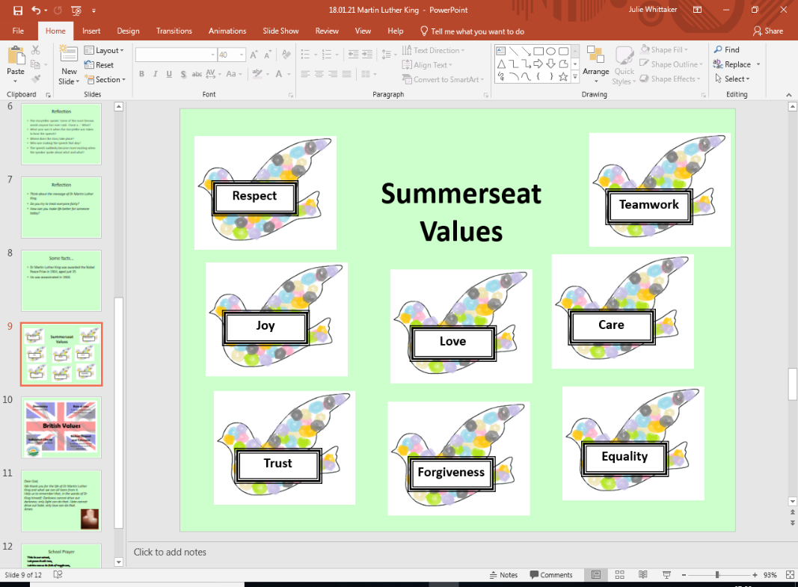
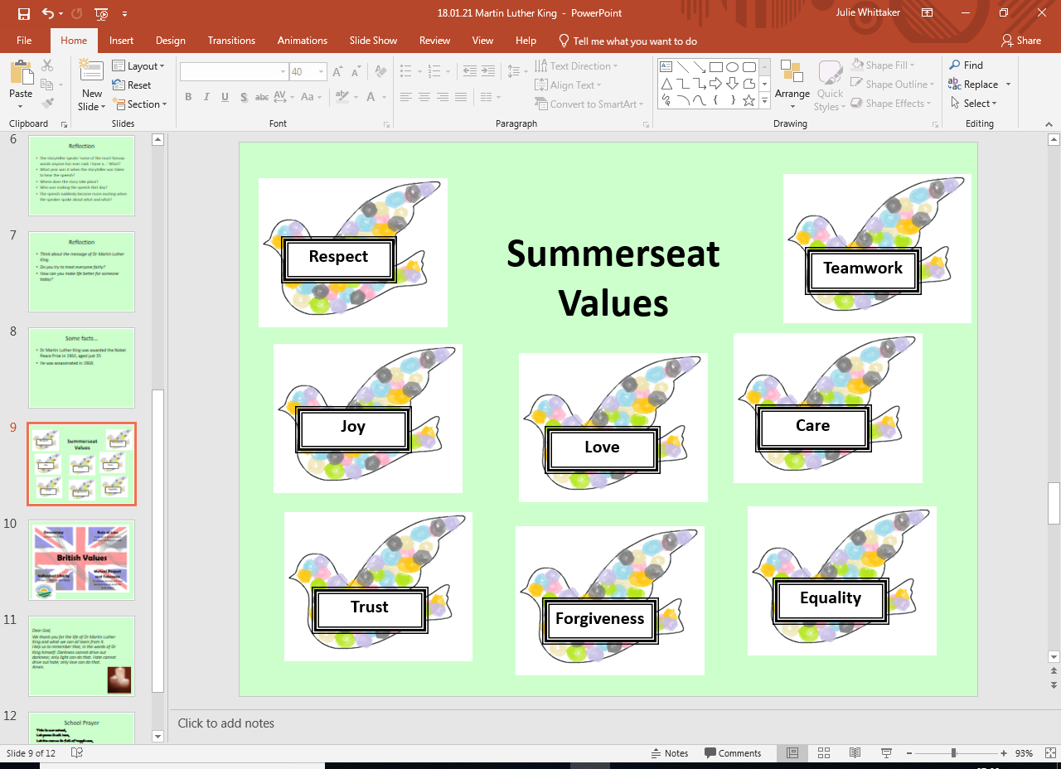

Summerseat Methodist Primary School – 2026-27 Long Term Plan – Cycle B

Autumn Term |  |  |  | Spring Term |  |  |  | Summer Term
English - Writing
Core Text: |  | Core Text: |  | Core Text: |  | Core Text: |  | Core Text: | Core Text:
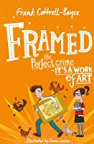 |  | 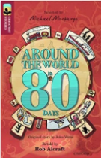 |  | 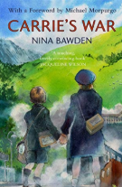 |  | 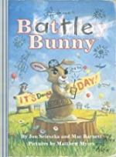 |  | 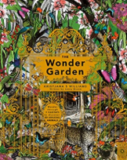 | 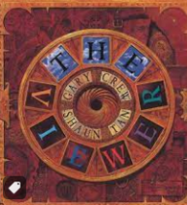
Framed  Frank Cottrell-Boyce |  | Around the World in 80 Days  Treetops –Original by Jules Verne |  | Carrie’s War  Nina Bawden |  | Battle Bunny -  Jon Scieszka, Mac Barnett, Matthew Myers |  | The Wonder Garden - Broom | The Viewer - Crew
Additional Text:  Sandy Cove (short story)  Bedgellert |  | Additional Text:  Elves and Sprites |  | Additional Text: |  | Additional Text: |  | Additional Text:  Pandora – film (gardens and oceans) | Additional Text:  Children’s history of Manchester
Poetry
An English Holiday – Rumble * | War Poetry (At C’mas look at Truce) http://www.keystage2literacy.co.uk/world-war-poetry.html |  |  |  |  |  | The Jaberwocky – Carroll (Nonsense) | The Lady of Shallot – Tennyson (Poet Laureate) |  |  | The Bees Still Buzz –  Ryan Williams *
Reading
Reading Comprehension |  | Reading Comprehension |  | Reading Comprehension |  | Reading Comprehension |  | Reading Comprehension | Reading Comprehension
Fiction |  | Fiction |  | Fiction |  | Fiction |  | Fiction | Fiction
 |  |  |  |  |  | 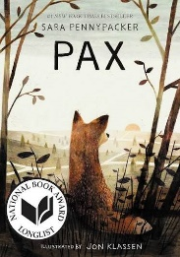 |  | 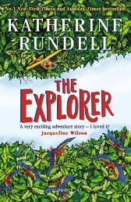 | 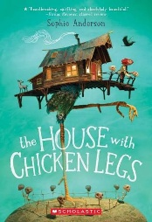
Framed  Frank Cottrell-Boyce |  | Around the World in 80 Days |  | Carrie’s War  Nina Bawden |  | Pax  Jon Klassen |  | The Explorer  Katherine Rundell | The House With Chicken Legs  Sophie Anderson
Non-Fiction |  | Non-Fiction |  | Non-Fiction |  | Non-Fiction |  | Non-Fiction | Non-Fiction
Complete Comprehension – Harry Houdini |  | Complete Comprehension – Hidden Figures |  | WW2 Letters and Poems Book |  | Complete Comprehension – Marius The Giraffe Killed at Copenhagen Zoo  Sea Wold decided to Stope Killer Whale Breeding Program – The Guardian
Poetry |  | Poetry |  | Poetry |  | Poetry |  | Poetry | Poetry
 |  | Complete Comprehension – For the Fallen |  |  |  |  |  |  | This is The Place – Tony Walsh
Handwriting
Mathematics
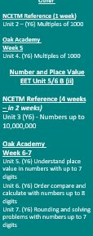  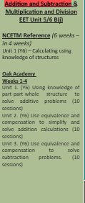
  Number & Place Value, Number Facts, Other
  NCETM Reference (5 weeks – revision unit – 3 weeks)
  Unit 1 (Y5)- Decimal Fractions
  Oak Academy
  Week 1-3
  Unit 1. (Y5) Understand tenths as parts of a whole, represent and calculate mentally
  Unit 2. (Y5) Compose and calculate with decimals including column addition and subtraction
  Unit 3. (Y5) Understand hundredths as part of a whole and represent
  Unit 4. (Y5) Use knowledge of decimals to solve problems in different contexts: length
  Use LBQ to relate to percentage equivalence
  Number & Place Value & Fractions
  EET Unit 5/6 B (iii)
  NCETM Reference (7 weeks in 2 week review)
  Unit 8 (Y5) - Fractions
  Oak Academy
  Unit 18 (Y5) . Multiply a proper fraction by a whole number (5 sessions)
  Unit 19. (Y5) Multiply improper fractions and mixed numbers by a whole number (5 sessions)
  Unit 20.(Y5) Find unit and non-unit fractions of whole numbers exploring parts and wholes (10 sessions)
  Unit 21. (Y5) Comparing fractions using equivalence and decimals (10 sessions)
  Addition and Subtraction, Multiplication and Division & Other
  NCETM Reference (4 weeks – 2 weeks before the holiday, 2 weeks after
  Unit 5 (Y6) - Multiplication and Division
  Oak Academy
  Week 6
  Unit 9 (Y6) Using Equivalence to Calculate
  Week 7
  Unit 10. (Y6) Multiplying and dividing by 2-digit numbers
  Addition and Subtraction, Multiplication and Division & Other
  NCETM Reference (4 weeks – 2 weeks before the holiday, 2 weeks after
  Unit 5 (Y6) - Multiplication and Division
  Oak Academy
  Week 1-2
  Unit 10. (Y6) Multiplying and dividing by 2-digit numbers
  Other
  NCETM Reference
  Unit 6 (Y6) - Area, Perimeter, position and direction
  Oak Academy
  Week 3-4
  Unit 11 (Y6) . Area, Perimeter, position and direction
  Fractions & Other
  NCETM Reference (6 weeks – 2 before the holiday, 4 after)
  Unit 7 (Y6) - Fractions and Percentages
  Oak Academy
  Week 5-6
  Unit 12 (Y6) Addition and Subtraction of Fractions
  Fractions & Other
  NCETM Reference (6 weeks – 2 before the holiday, 3 after)
  Unit 7 (Y6) - Fractions and Percentages
  Oak Academy
  Week 1
  Unit 13. (Y6) Comparing fractions
  Week 2
  Unit 14. (Y6) Multiplication and division of fractions
  Week 3-4
  15. (Y6) Understanding percentages
  Other
  NCETM Reference (1 week)
  Unit 8 (Y6) - Statistics
  Oak Academy
  Week 5
  Unit 16. (Y6) Statistics
  Addition and Subtraction & Multiplication & Division
  NCETM Reference (2 weeks – 1 before holiday, 1 week after)
  Unit 9 (Y6) - Ratio and Proportion
  Oak Academy
  Week 6
  Unit 17. (Y6) Ratio and proportion (Part 1)
  Addition and Subtraction & Multiplication & Division
  NCETM Reference (2 weeks – 1 before holiday, 1 week after)
  Unit 9 (Y6) - Ratio and Proportion
  Oak Academy
  Week 6
  Unit 17. (Y6) Ratio and proportion (Part 2)
  SATS REVISION
  Week 2-3
  SATS
  Week 4
  Other
  NCETM Reference (1 week)
  Unit 13 (Y6) – Mean Average
  Oak Academy
  Week 5
  Unit 21 (Y6) Mean Average
  Week 6
  Consolidation
  Geometry
  NCETM Reference (2 weeks)
  Unit 4 (Y6) - Draw, compose and decompose shapes
  Oak Academy
  Week 1-2
  Unit 8. (Y6) Draw, compose and decompose shapes
  Addition and Subtraction & Multiplication & Division
  NCETM Reference (1 week)
  Unit 10 (Y6) – Calculating using knowledge of structures (2)
  Oak Academy
  Week 3
  Unit 18. (Y6) Calculating using knowledge of equivalence in addition and subtraction
  Addition and Subtraction & Multiplication and Division
  NCETM Reference (2 weeks)
  Unit 11 (Y6) Solving problems with two unknowns
  Week 4-5
  Oak Academy
  Unit 19. (Y6) Solving problems with two unknowns
  Week 6
  Consolidation
Science
Biology  Evolution & Inheritance (variation, adaptation, fossils) |  |  | Physics -Space  Sustainability - Global Warming | Biology  The Circulatory system | Biology  Diet, Drugs and Lifestyle |  |  | Physics - Electricity  Sustainability - Renewable energy |  |  | Biology  Living things and their habitat
RE
Why do Hindus want to be good? |  |  |  | 2b.2CREATION/  FALL: Creation & Science – Conflict or Complimentary? |  | 2b.6 SALVATION: What did Jesus do to save Human Beings? Easter OR 2b.7: SALVATION:  What difference does the resur-rection make to Christians? Easter |  | 2b.8 KINGDOM OF GOD: What kind of King is Jesus? OR 2b.3 PEOPLE OF GOD: How can following God bring freedom and Justice? | How does faith help people when life gets hard?
History
 |  |  |  | A study of an aspect or theme in British history that extends understanding beyond 1066  World War II - Battle of Britain |  |  |  |  |  | Local History of Manchester  (History including local study and Geography)
Geography
Britain’s National Parks |  |  | The Seven Wonders of the World  (Geographical Concepts) |  |  |  |  | North America
Art
Painting  Vincent van Gogh -Flowers |  |  |  |  | Digital Art / Drawing  Renoir - Umbrellas |  |  |  |  | Drawing / Painting  Banksy  Buildings (perspective) / Banksy
DT
 |  |  | Electrical Systems  More complex circuits & switches  Moon Buggy to carry a passenger | Textiles  Combining skills and materials  Mobile Phone pouch  Designer: Vivienne Westwood |  |  |  | Food  Celebrating culture  Road Trip USA  Making burgers & pie
PE
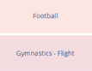 |  |  |  | 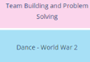 |  | 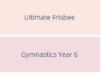 |  |  | 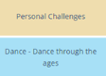
PSHE
Knowing Me, Knowing You |  | Relationships and the Wider World |  | Keeping Healthy |  | Keeping Safe (Inc. CWP Preventing Early Use) |  | Friends, Family & SRE | Friends, Family & SRE
 |  | Tango Makes Three – Justin Richardson and Peter Parnell |  | Rose Balnche – Ian McEwan and Roberto Innocenti |  | Where Poppies Grow – Hilary Robinson and Martin Impey |  | The Artist Who Painted A Horse Blue – Eric Carle | How To Heal a Broken Wing- Bob Graham
One lesson every half term has an Anti-Bullying and No Outsiders focus.
Computing
6-Networks  4 weeks  5-Databases  4 weeks |  | 6-Blogging  6 weeks |  | 5-Concept maps  4 weeks  6-Introduction to Python  4 weeks |  | Coding  6 weeks |  | 5-Spreadsheets  6 weeks | 6-Data detectives  4 weeks
Online Safety – Delivered throughout the year using Evolve Resources

French
Actions |  | In France |  | Jobs |  | The Environment |  | Family | A Weekend With Friends
Music
The Fresh Prince of Bel Air |  | Songs For Christmas |  | Western Classic to  1940: 20th Century:  Holst ‘Mars from the  Planets’  Western Tradition &  Film post 1940:  Zimmer - Earth |  | Glokenspiel Stage  2, then song book.  / Key board  beginner |  | Glockenspiel /  Key board | Oasis vs The  Beatles
Visits and Visitors / Hook
 |  | Jodrell Bank |  | Fusilier Museum |  |  |  |  | Anderton Centre Day Visit

Writing
Oracy for Writing
Performs writing confidently to an audience, using intonation deliberately.
Discusses own and others’ writing critically, considering audience impact.
Selects appropriate registers for different contexts.

Composition: Sentences
Sustains a wide range of sentence structures for clarity and effect.
Uses passive voice strategically.
Maintains correct verb forms and tenses throughout.
Links ideas across paragraphs with cohesive devices.

Punctuation
Uses all KS2 punctuation accurately, including commas, hyphens and ellipses.

Composition: Context, Audience, Purpose
Plans and writes texts with precise vocabulary, tone and formality.
Manipulates grammar and vocabulary confidently to achieve intended effects
Maintains a clear viewpoint and includes engaging, purposeful detail.

Composition: Narrative
Writes extended narratives with coherent, evenly paced structure.
Crafts purposeful openings and resolutions.
Creates atmosphere through precise vocabulary and structural choices.
Develops plot with clear links between paragraphs.

Composition: Non-narrative
Constructs texts with strong introduction, developed points and effective conclusion.
Uses paragraphs and cohesion to achieve effect.
Selects and applies organisational and presentational devices to engage the reader.
Summarises longer passages independently when needed.

Composition: Editing
Makes grammar, vocabulary and punctuation changes to enhance effect.
Ensures consistent tense, agreement and register.
Critically evaluates own and others’ writing for effectiveness and impact.

Spelling
Spells KS1 and KS2 words accurately, including homophones and words with silent letters.
Uses dictionaries and thesauri efficiently.
Applies knowledge of morphology, etymology and rules from Appendix 1 NC.

Reading
Oracy & Reading
Discusses a wide range of texts, building on others’ ideas and challenging views. Uses probing questions and evaluation to explore meaning.
Constructs detailed responses, recommends books, and justifies opinions. Reads aloud with expression and clarity.
Recites a wider range of poetry by heart.
Uses formal presentation and debate to explain understanding.
Discusses language that has had a personal impact.
Word Reading & Decoding
Understands words with prefixes and suffixes from the Year 5/6 curriculum.
Language in Context: V
Talks about a broad vocabulary and independently explores unknown words. Shows understanding of vocabulary in different contexts. Finds words or phrases with particular meanings, or synonyms that match a given word.
Comprehension – Retrieval: R
Skims and scans whole texts efficiently. Retrieves key details and quotations to show understanding.
Answers comprehension questions with evidence and quotations.
Distinguishes between fact and opinion.
Comprehension – Sequencing & Summarising: S
Summarises main ideas, events and information accurately from fiction and non-fiction.
Makes selective comparisons within and across texts.
Comprehension – Inference: I / P
Finds evidence to prove or disprove statements about character or setting. Uses clues from action, dialogue and description to interpret meaning. Empathises with characters’ viewpoints.
Explains and justifies inferences with evidence.
Makes developed inferences, drawing on text and wider experience.
Identifies author viewpoints within and across texts.
Makes secure, developed predictions about plot or character, justifying with evidence.
Comprehension – Choice of Language: WP
Explains the effect of author’s language and structure.
Analyses figurative language (e.g. metaphor, simile, imagery, idiom, personification).
Identifies the impression words and phrases give the reader.
Comprehension – Themes & Conventions: E / C
Identifies the main message of a poem or story.
Uses text format and features to determine type and purpose.
Explains how organisation and presentation impact the reader.
Identifies themes and conventions across genres.
Explains how narrative structure contributes to meaning.
Recognises and evaluates different poetic forms.
Compares and evaluates texts against their purpose.


A Year Six Child
English

Speaking

• Talk confidently and fluently in a range of situations, using formal and Standard English as appropriate
• Ask questions to develop ideas and make contributions that take account of others’ views
• Explain ideas and opinions giving reasons and evidence
• Take an active part in discussions, taking different roles
• Listen to and consider the views and opinions of others in discussions
• Make contributions to discussions, evaluating others’ ideas and responding to them
• Sustain and argue a point of view in a debate, using formal language of persuasion
• Express possibilities using hypothetical and speculative language in science and when discussing reading
• Engage listeners through choice of vocabulary and register according to the context
• Perform own compositions, using appropriate intonation and volume and expression so that literal and implied meaning is made clear
• Perform poems or plays from memory, making deliberate choices about how they convey ideas about characters, contexts and atmosphere

Handwriting

• I can write legibly, fluently and with increasing speed.
• I can choose which shape of letter to use when given choices and deciding whether or not to join specific letters.
• I can choose the writing implement that is best suited to a task.

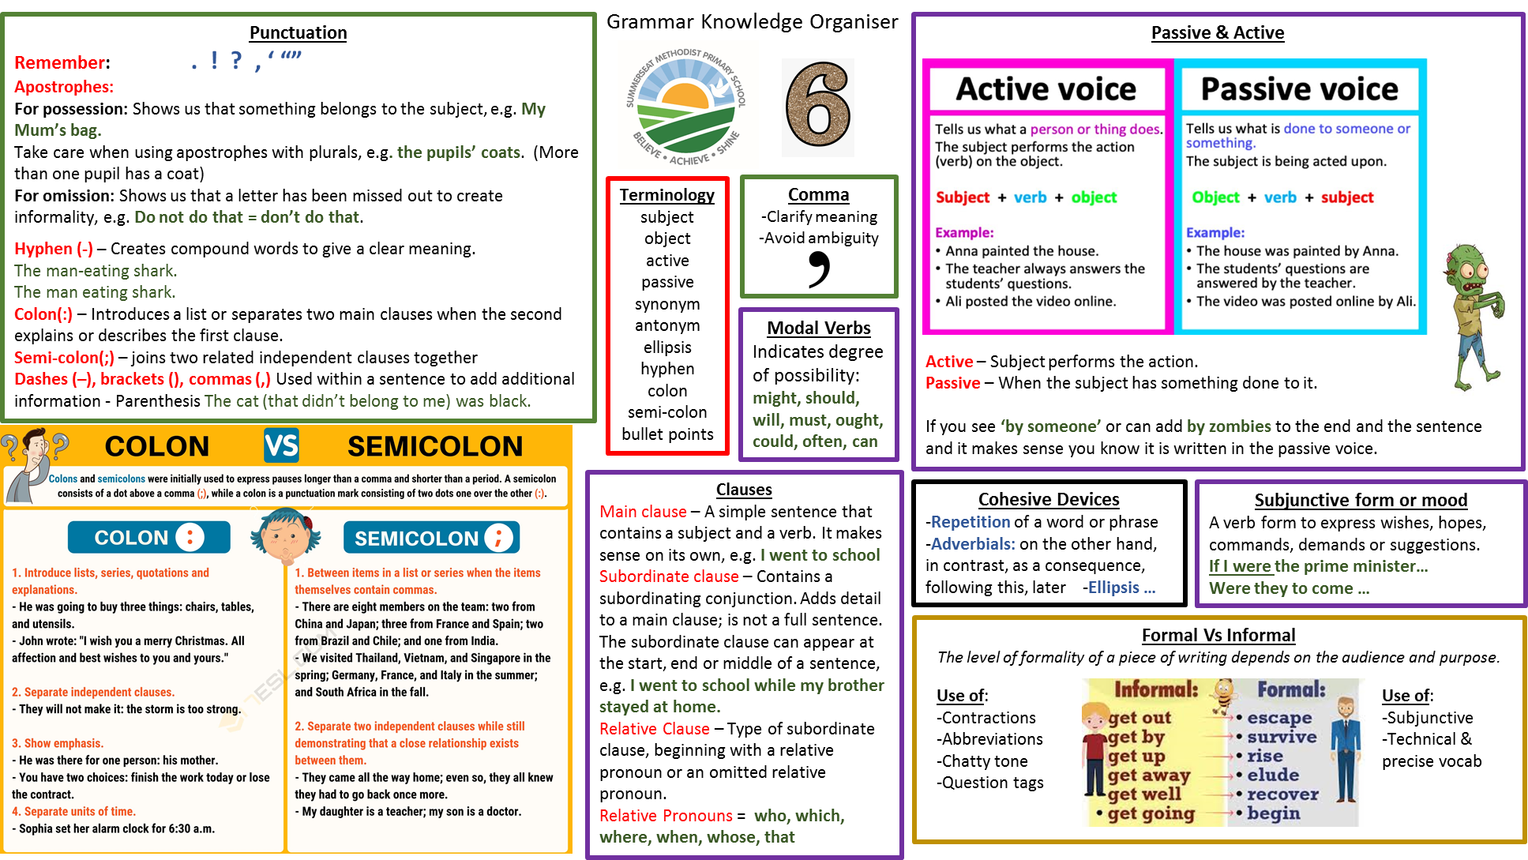

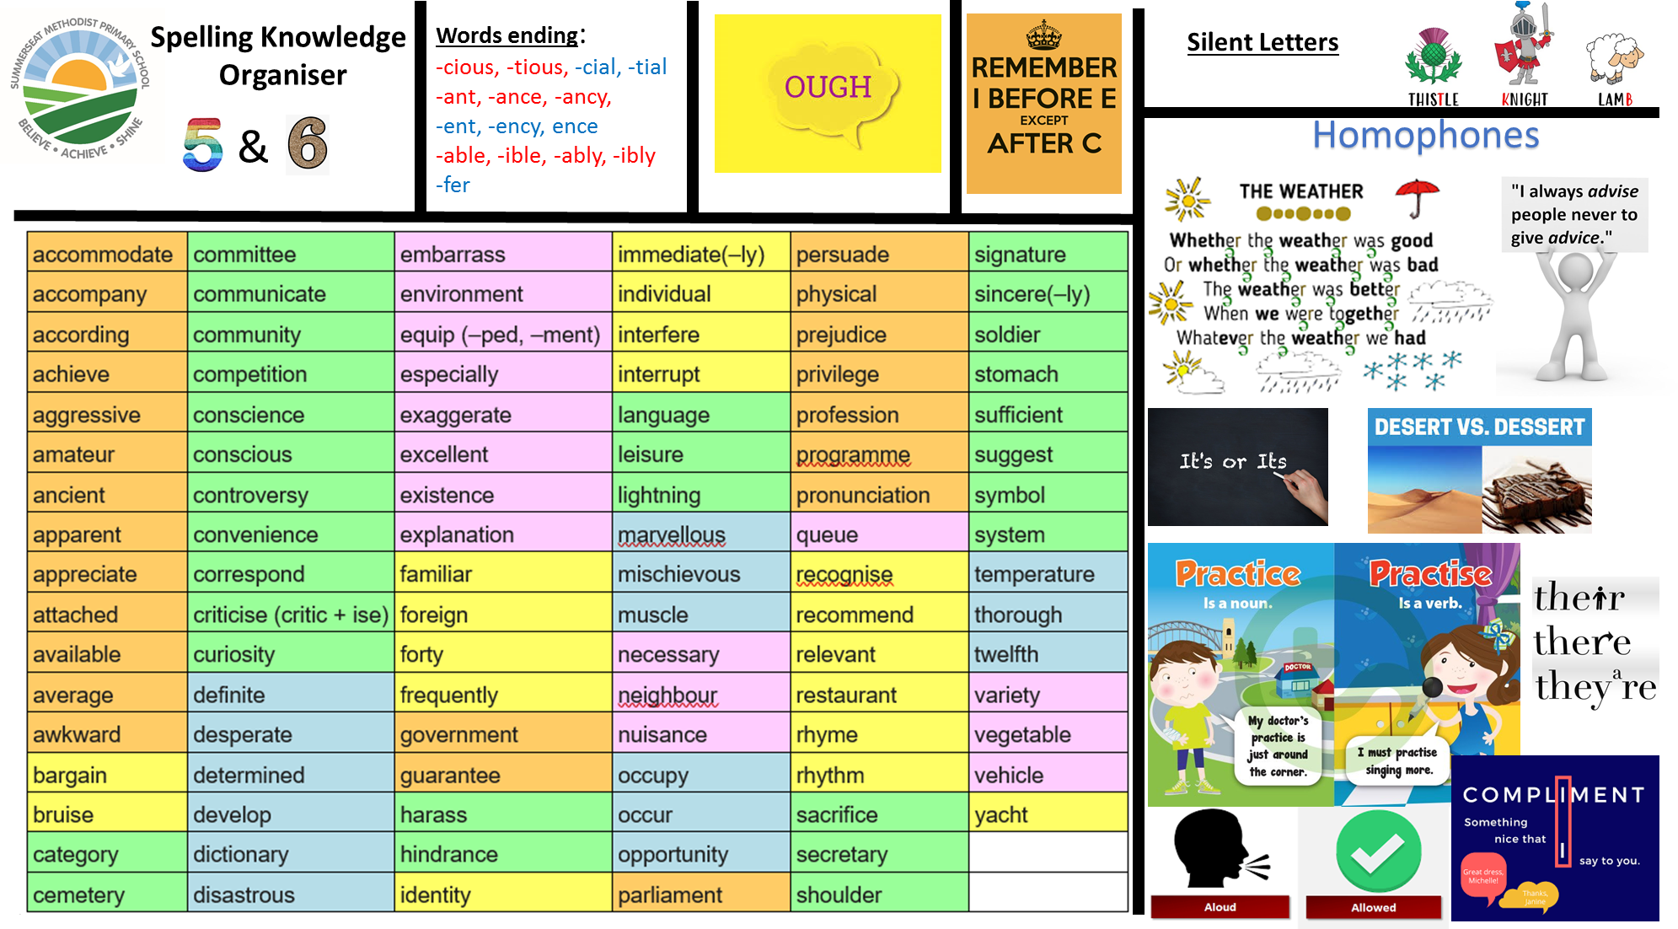


Being a Mathematician
Fractions & Number
• Read, write, order and compare numbers up to 10,000,000 and determine the value of each digit
• Round any whole number to a required degree of accuracy
• Solve problems which require answers to be rounded to specified degrees of accuracy
• Identify the value of each digit in numbers given to 3 decimal places
• Use negative numbers in context, and calculate intervals across zero
• Solve number and practical problems that involve all of the above
• Solve problems involving all four operations
• Perform mental calculations, including with mixed operations and large numbers
• Multiply and divide numbers by 10, 100 and 1,000, giving answers to 3 decimal places
• Use knowledge of order of order of operations to carry out calculations involving all four operations
• Solve addition and subtraction multi-step problems in contexts, deciding which operations to use and why
• Multiply multi-digit numbers up to four-digits by a two-digit whole number using the formal written method of long multiplication
• Multiply one-digit numbers with up to two decimal places by whole numbers
• Divide numbers up to four-digits by a single-digit whole number using the formal written method of short division
• Divide numbers up to four-digits by a two-digit whole number using the formal written method of long division
• When dividing, interpret remainders as whole number remainders, fractions, or by rounding, as appropriate for the context
• Identify common factors, common multiples and prime numbers
• Use estimation to check answers to calculations and determine, in the context of a problem, an appropriate degree of accuracy
• Use common factors to simplify fractions
• Use common multiples to express fractions in the same denomination
• Add and subtract fractions with different denominators and mixed numbers, using the concept of equivalent fractions
• Multiply simple pairs of proper fractions, writing the answer in its simplest form
• Divide proper fractions by whole numbers
• Associate a fraction with division and calculate decimal fraction equivalents
• Recall and use equivalences between simple fractions, decimals and percentages, including in different contexts
• Solve problems involving the calculation of percentages, (for example, of measures) such as 20% of 440

Being a Mathematician
Fractions, Measurement, geometry & statistics

• Solve problems involving the relative sizes of 2 quantities where missing values can be found by using integer multiplication and division facts
• Solve problems involving similar shapes where the scale factor is known or can be found
• Solve problems involving unequal sharing and grouping using knowledge of fractions and multiples
• Read, write and use standard units of measurement with precision and accuracy
• Convert measurements of length, mass, volume and time from a smaller unit of measure to a larger unit, and vice versa, using decimal notation up to three decimal places
• Solve problems involving the calculation of units of measure
• Convert between miles and kilometres
• Accurately measure area and perimeters of shapes and understand that shapes with the same area can have different perimeters and vice versa
• Use formulae to calculate the area of parallelograms and triangles
• Estimate, calculate and compare volume of cubes and cuboids using standard units of metric measurement
• Draw 2-D shapes using given dimensions and angles
• Recognise, describe and build simple 3-D shapes, including making nets
• Compare and classify geometric shapes based on their properties and sizes and find unknown angles in any triangles, quadrilaterals, and regular polygons
• Illustrate and name parts of circles, including radius, diameter and circumference and know that the diameter is twice the radius
• Recognise angles where they meet at a point, are on a straight line, or are vertically opposite, and find missing angles
• Use simple formulae
• Generate and describe linear number sequences
• Express missing number problems algebraically
• Find pairs of numbers that satisfy an equation with two unknowns
• Enumerate possibilities of combinations of two variables

A Year One Child
Mathematics

Addition Strategies

Subtraction Strategies

Multiplication Strategies

Division Strategies

For more detail on our mathematical strategies, please see our calculation policy and progression document.
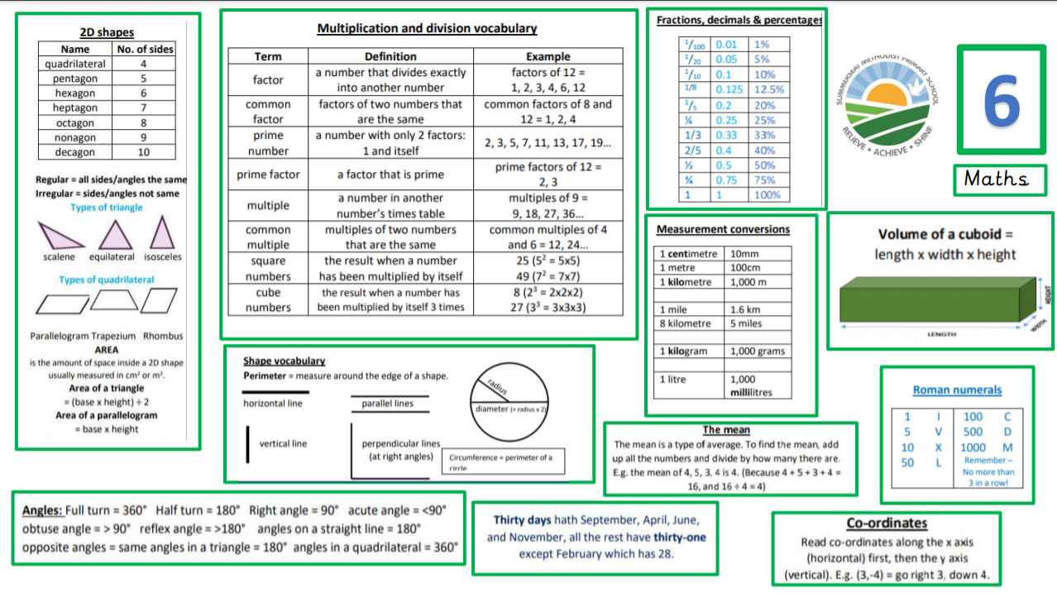

INSERT KOS for FIRST TERM

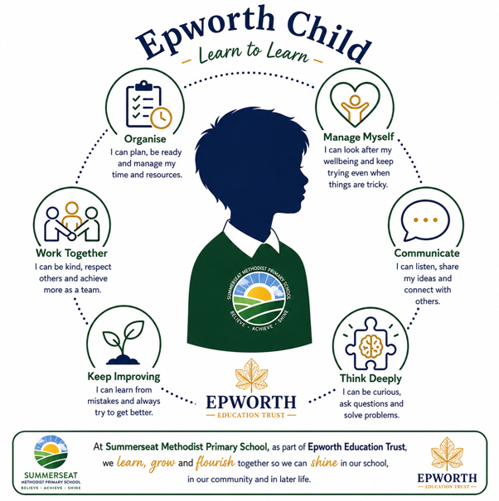
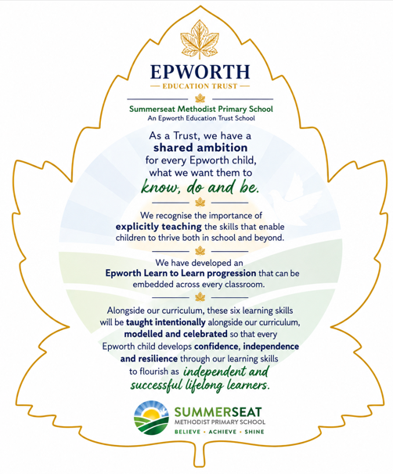
Learn to Learn Skills

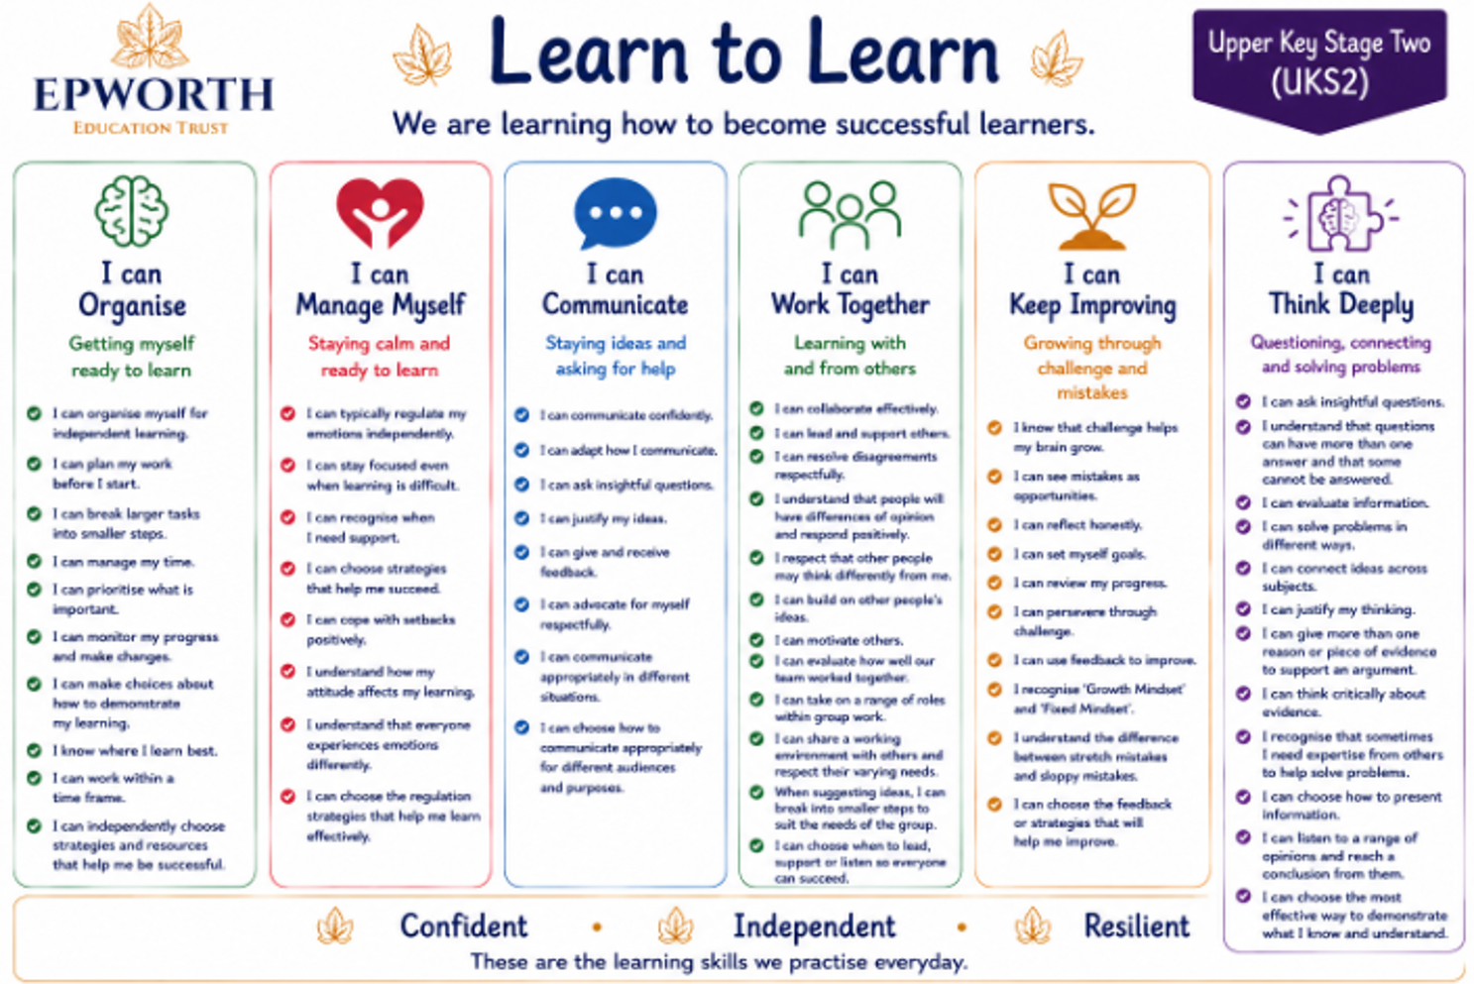
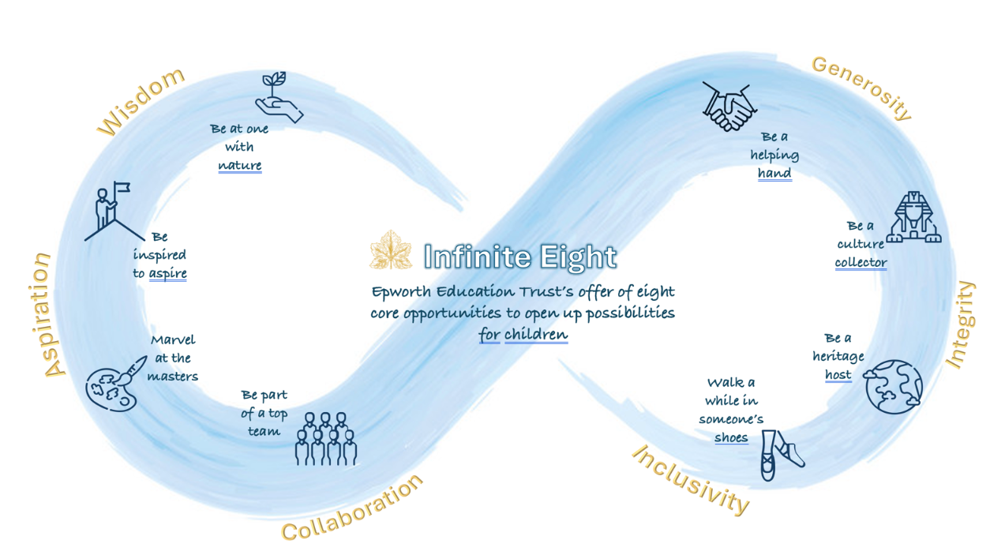
Be a culture collector
hjff

Be a heritage host

Walk a while in someone’s shoes

Be part of a top team

Marvel at the masters

Be inspired to aspire

Be a helping hand

Be at one with nature

Infinite Eight
Enrichment Offer
The ‘Infinite Eight’ strategy outlines Epworth’s offer of eight opportunities for children to enjoy meaningful experiences beyond the taught curriculum during their time in our Epworth Trust schools.
Listed below are the minimum experiences your child will take part in this year.

