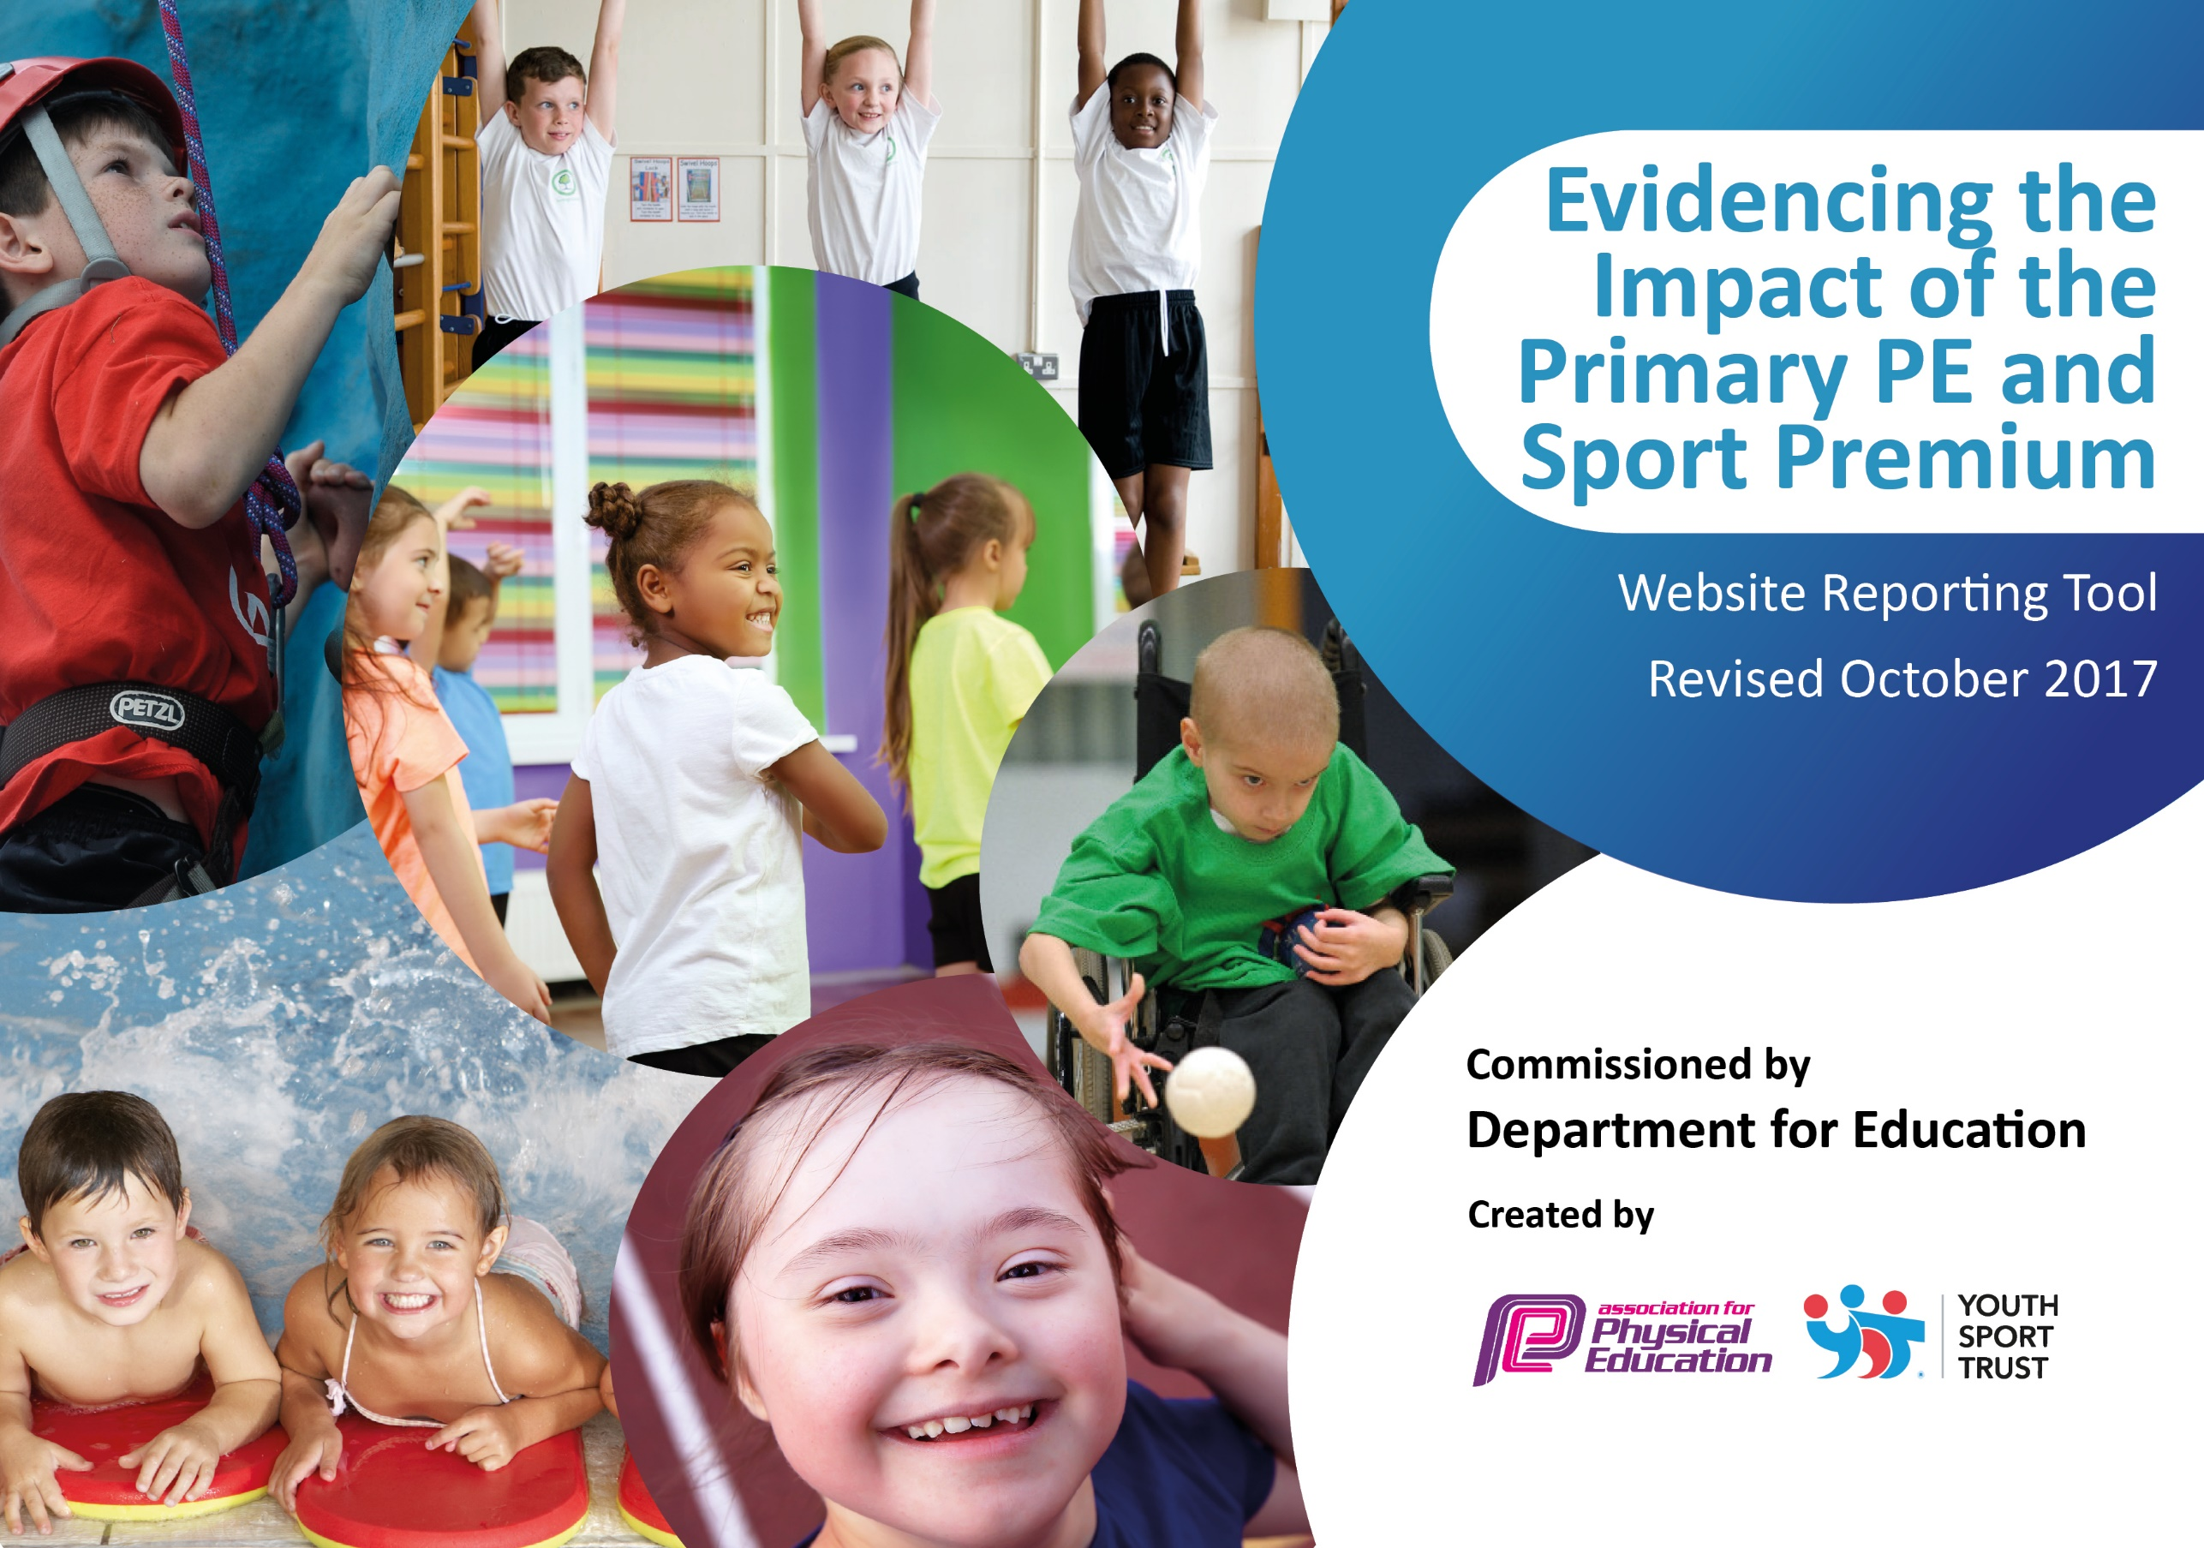

Sports Premium
2020-21

Schools must use the funding to make additional and sustainable improvements to the quality of PE and sport they offer. This means that you should use the Primary PE and Sport Premium to:

- develop or add to the PE and sport activities that your school already offers
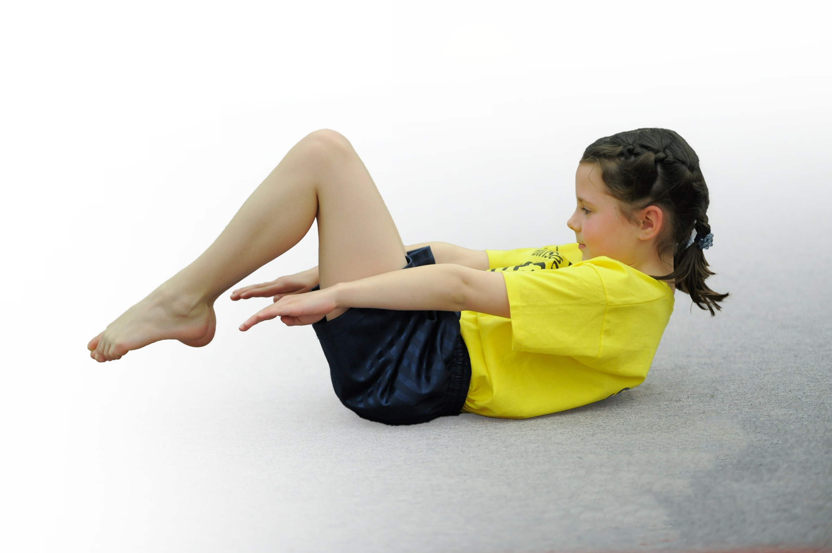
- build capacity and capability within the school to ensure that improvements made now will benefit pupils joining the school in future years

Please visit gov.uk for the revised DfE guidance including the 5 key indicators across which schools should demonstrate an improvement. This document will help you to review your provision and to report your spend. DfE encourages schools to use this template as an effective way of meeting the reporting requirements of the Primary PE and Sport Premium.

We recommend you start by reflecting on the impact of current provision and reviewing the previous spend.
Under the Ofsted Schools Inspection Framework, inspectors will assess how effectively leaders use
the Primary PE and Sport Premium and measure its impact on outcomes for pupils, and how effectively governors hold them to account
for this.

Schools are required to publish details of how they spend this funding as well as on the impact it has on pupils’ PE
and sport participation and attainment.
We recommend regularly updating the table and
publishing it on your website as evidence
of your ongoing review into how you are using the money
to secure maximum, sustainable impact. To see an example of how to complete the table please click HERE.

Support for review and reflection - considering the 5 key indicators from DfE, what development needs are a priority for your setting and your students now and why? Use the space below to reflect on previous spend, identify current need and priorities for the future.

Key achievements to date: | Areas for further improvement and baseline evidence of need:
- 1st place in the Bury schools weekly warrior ‘personal challenge’ competition  - A range of after school sports clubs provided for pupils to attend across the school  - After school clubs delivered by coaches and teachers  - Staff training via P.E. coaches  - Pupils take part in inter-school competition  - A range of sports equipment for pupils to use  - Enhanced environment and resources for high quality PE and sport. EYFS playground improved for outdoor learning.  - Continue to improve the children’s attitude towards physical activity and healthy lifestyles and create opportunities for those pupils who are disengaged. | - Adaption of the P.E curriculum in line with COVID-19 government guidance.  - Develop the range of after school clubs on offer –contact more outside agencies for specialised clubs. Once COVID-19 allows  - Begin a Change 4 Life club for least active children. Once COVID-19 allows – include playground leaders in developing this.  - Use tracking systems of data for clubs and competitive attendance to target the least active pupils from the previous year.  - To increase the opportunity, take part in inter school competitions  - Organise intra school competitions to develop competitive opportunities  - Develop Forest School programme via staff training  - Increase gross motor skills of EYFS pupils- Tots on Tyres  - Offer bikeability to students  - The whole staff attitude to PE is linked into mental well-being and being physically active  - Take part in the Virtual Games programme in autumn 2020.  - Continue to develop the ‘Personal Challenge’ in school  - Achieve a school games mark award when they recommence

Meeting national curriculum requirements for swimming and water safety | Please complete all of the below:
What percentage of your Year 6 pupils could swim competently, confidently and proficiently over a distance of at least 25 metres when they left your primary school at the end of last academic year? | 91%
What percentage of your Year 6 pupils could use a range of strokes effectively [for example, front crawl, backstroke and breaststroke] when they left your primary school at the end of last academic year? | 75%
What percentage of your Year 6 pupils could perform safe self-rescue in different water-based situations when they left your primary school at the end of last academic year? | 66%
Schools can choose to use the Primary PE and Sport Premium to provide additional provision for swimming but this must be for activity over and above the national curriculum requirements. Have you used it in this way? | Yes/No

Action Plan and Budget Tracking
Capture your intended annual spend against the 5 key indicators. Clarify the success criteria and evidence of impact that you intend to measure to evaluate for students today and for the future.

Academic Year: 2020/21 | Total fund allocated: £16,850 | Date Updated 18/9/20
Key indicator 1: The engagement of all pupils in regular physical activity – Chief Medical Officer guidelines recommend that primary school children undertake at least 30 minutes of physical activity a day in school |  |  |  | Percentage of total allocation:
 |  |  |  | 5%
School focus with clarity on intended impact on pupils: | Actions to achieve: | Funding allocated: £2000 | Evidence and impact: | Sustainability and suggested next steps:
- Increase the range of after school clubs to target all year groups  - Introduce playground activities for pupils at lunch time  - Introduce Playground leaders – ‘Summerseat Stars’  - Relaunch the ‘daily mile’  - Ensure children have a positive attitude to healthy eating and lifestyles  - Engage least active children in physical activity  - Increase opportunities for outdoor learning for EYFS | - After school clubs offered to all year groups and changed each half term  - Enquire with more outside agencies to provide specialist coaching eg. Martial arts  - Lunch time volunteers set up & timetabled – appointment of an additional member of welfare staff. Specific year groups targeted. Children to vote for their ‘Summerseat Stars’  - Areas of the yard and field reserved for activities / daily mile  - Set up change 4 life club  - Identify pupils who are disengaged and engage them in clubs. (Focus on disadvantaged first)  - Forest school training for staff member |  | There were some limits to what could be achieved in 2020-21 in relation to sports clubs due to Covid restrictions that were in place. However, clubs were held at lunchtime and after school in bubbles as soon as guidance was updated. After school clubs continue to change every half term to ensure a full range of sports to capture the imagination of others.  Videos were provided by Go4It Sports during lockdown to provide ideas for sporting activities that could be achieved at home during lockdown with minimal resources. This meant children and families were still able to get involved in physical activity.  Summerseat Stars trained to support introduction of playground games – this was restricted to bubbles and ‘Summerseat Stars’ will roll over into 2021-22 so they can achieve their goals.  Every class took part in Forest School for the first time this year. This was supplemented by a Forest School after school club. Engagement in this was good and pupil voice was positive.  Forest School training completed, portfolios submitted and awaiting validation. All training complete. | Look into training for lunch time volunteers & lunch time welfare staff  Re-establish playground zones  Further resources purchased to ensure a range of activities for pupils- dinner time  Playground marking to facilitate games opportunities.  Target pupils who are the least active for clubs  Offer after school clubs focusing on healthy lifestyles. E.g. healthy eating/cooking classes
Key indicator 2: The profile of PE and sport being raised across the school as a tool for whole school improvement |  |  |  | Percentage of total allocation:
 |  |  |  | 0%
School focus with clarity on intended impact on pupils: | Actions to achieve: | Funding allocated: £2000 | Evidence and impact: | Sustainability and suggested next steps:
- EYFS ensures the 10 fundamental movement skills are taught  - The majority of children leave KS1 with the 10 fundamental movement skills  - Ensure that grounds are appropriate for P.E.- Reception pupils  - Pupils to take part in activities that are not normally part of the curriculum- increase the diversity of sport  - Promote sporting opportunities: website, Twitter, celebration assembly,  - Work towards achieving School Games award when reintroduced in 21/22  - Improve children’s confidence, resilience and raise aspirations | - Initial baseline assessment carried out by EYFS teacher with assistance from PE lead if needed  - Assistance with baselines  - Invest in the development of the EYFS outdoor area  - Take pupils to clubs to engage in activities  - Communicate the importance of sport and the School Games Values via various media.  - Ensure prerequesists are met and set up necessary actions to achieve a School Games award when up and running again after Covid -19  - Display children’s sporting achievements – inform parents of success in weekly newsletter |  | EYFS outdoor area has been transformed to provide opportunity for gross motor activities. Areas are now defined and should ensure children are physically active daily.  Sports coaches have provided training for staff on 10 fundamental movement skills through joint lesson delivery. This can then be transferred to daily teaching / PE teaching.  Sports engagement has been a focus for social media and staff CPD. All staff know how important this is and the priority placed on it through school.  Additional time was allocated to sports on return i.e. Cricket Sessions in addition to PE lessons, additional swimming to ensure children met the swimming standard, Forest School sessions for all classes, Relax Kids opportunities, bikeability and ‘Tots on Tyres’. Engagement with sports was given priority.  Sporting achievement board created within the main school hall to celebrate achievement and raise profile. Achievements also communicated on Twitter.  Commitment demonstrated through sign-up to Bury programme membership (However this was restricted due to Covid) | Work towards achieving School Games award and continue to engage with and celebrate sporting achievements. Highlight different types of performance opportunities i.e. Excel, aspire, etc.

Key indicator 3: Increased confidence, knowledge and skills of all staff in teaching PE and sport |  |  |  | Percentage of total allocation:
 |  |  |  | 54%
School focus with clarity on intended  impact on pupils: | Actions to achieve: | Funding  allocated: £6000 | Evidence and impact: | Sustainability and suggested  next steps:
1.Continue to invest in staff CPD – when COVID – 19 rules allow invite BSSP in school for specialist sessions.  2.Teachers to wear PE kits for lessons and support staff to be actively involved in the lessons with teachers. Each PE lesson to be an hour (two a week).  3. Ensure all staff are using the core skills to assess P.E  4. Develop the role of the sports lead | - Utilise sports coaches through SSP to work alongside class teachers  - Ensure classes are receiving 2 hours of P.E per week.  - Ensure staff teaching P.E are aware of the core skills and how to assess – P.E lead to action this  - Appoint new P.E lead (N.T) |  | PE Lead was effective in post and increasing engagement and staff strength.  Lesson observation, pupil feedback and pupil skills are progressive  Sports lead is a model of good practice and can aid less experienced staff. | Induct new PE leader to share good practice and ideas with staff. Ensure they have confidence, knowledge and skills to support colleagues effectively.  Continue to work with sports providers to provide effective CPD in order to increase the skill level of staff (Staffing changes means this needs to continue)
Key indicator 4: Broader experience of a range of sports and activities offered to all pupils |  |  |  | Percentage of total allocation:
 |  |  |  | 42%
School focus with clarity on intended  impact on pupils: | Actions to achieve: | Funding  allocated: £4700 | Evidence and impact: | Sustainability and suggested  next steps:
Additional achievements:  1.Engage all children through a varied sports programme and  increase range of extra-curricular activities delivered after-school  2.Develop Outdoor Learning / Forest School leader in school  3.Resource Forest School area to ensure grounds are suitable  4.Hold a Health & Fitness Fortnight to promote physical and mental health – Race for life, Smoothie bike company, scootability  - Participation in Outdoor Adventurous Activities and Residential. (dependant on COVID-19 guidelines). | - Purchase new equipment to deliver a wide and varied PE and school sport programme  - Forest School training for identified member of staff  - Purchase resources for forest school  - Successful H&F fortnight  Access ‘Tot’s on Tyres’ and Learn 2 Ride programmes. Book in bikeability – Y4 and Y6  - Health and Fitness fortnight completed |  | ‘Tots on Tyres’ and ‘Biekability’ went ahead this year.  Staff member successfully completed Forest School training and full programme offered to all classes this year. Resources are now in place and Forest School is sustainable in school.  Outdoor adventurous planned for bubbles in house: foot golf / crazy golf / extended Forest School sessions / orienteering  Coaches and staff have been secured for after school clubs – staff confidence is growing  Coaches change the year groups they work with each half term | Embed a programme of Forest School for all classes across the year. Also offer this as an after-school club for targeted year groups and pupils.  Monitor PE equipment and control stock – replace/replenish through core budget  Review clubs on offer- target specific year groups/pupils  Individual staff to lead / champion different sports to provide range and support PE lead. This should build engagement. Coaches to support training offer for this.
Key indicator 5: Increased participation in competitive sport |  |  |  | Percentage of total allocation:
 |  |  |  | 5%
School focus with clarity on intended  impact on pupils: | Actions to achieve: | Funding  allocated: £600 | Evidence and impact: | Sustainability and suggested  next steps:
1.To give opportunities to all our children to take part in competitions at a variety of levels.  2.To raise aspirations  3.To promote the enjoyment of physical activity | 1.Sign up for competitions: local authority & school to school, introduce house competitions  2.Celebrate achievements in assemblies and newsletter. Increase pupils taking part in competitions across year groups  3. Share success and school games values |  | Development of intra school competition – half termly opportunities were built in through house competitions. This was crucial due to Covid restrictions. | Individual staff to lead / champion different sports to provide range and support PE lead. Coaches to support training offer for this. Staff to find competitive opportunities in their identified sport.  Build on intra school competition.

Updated by N.Taylor 25/9/20

