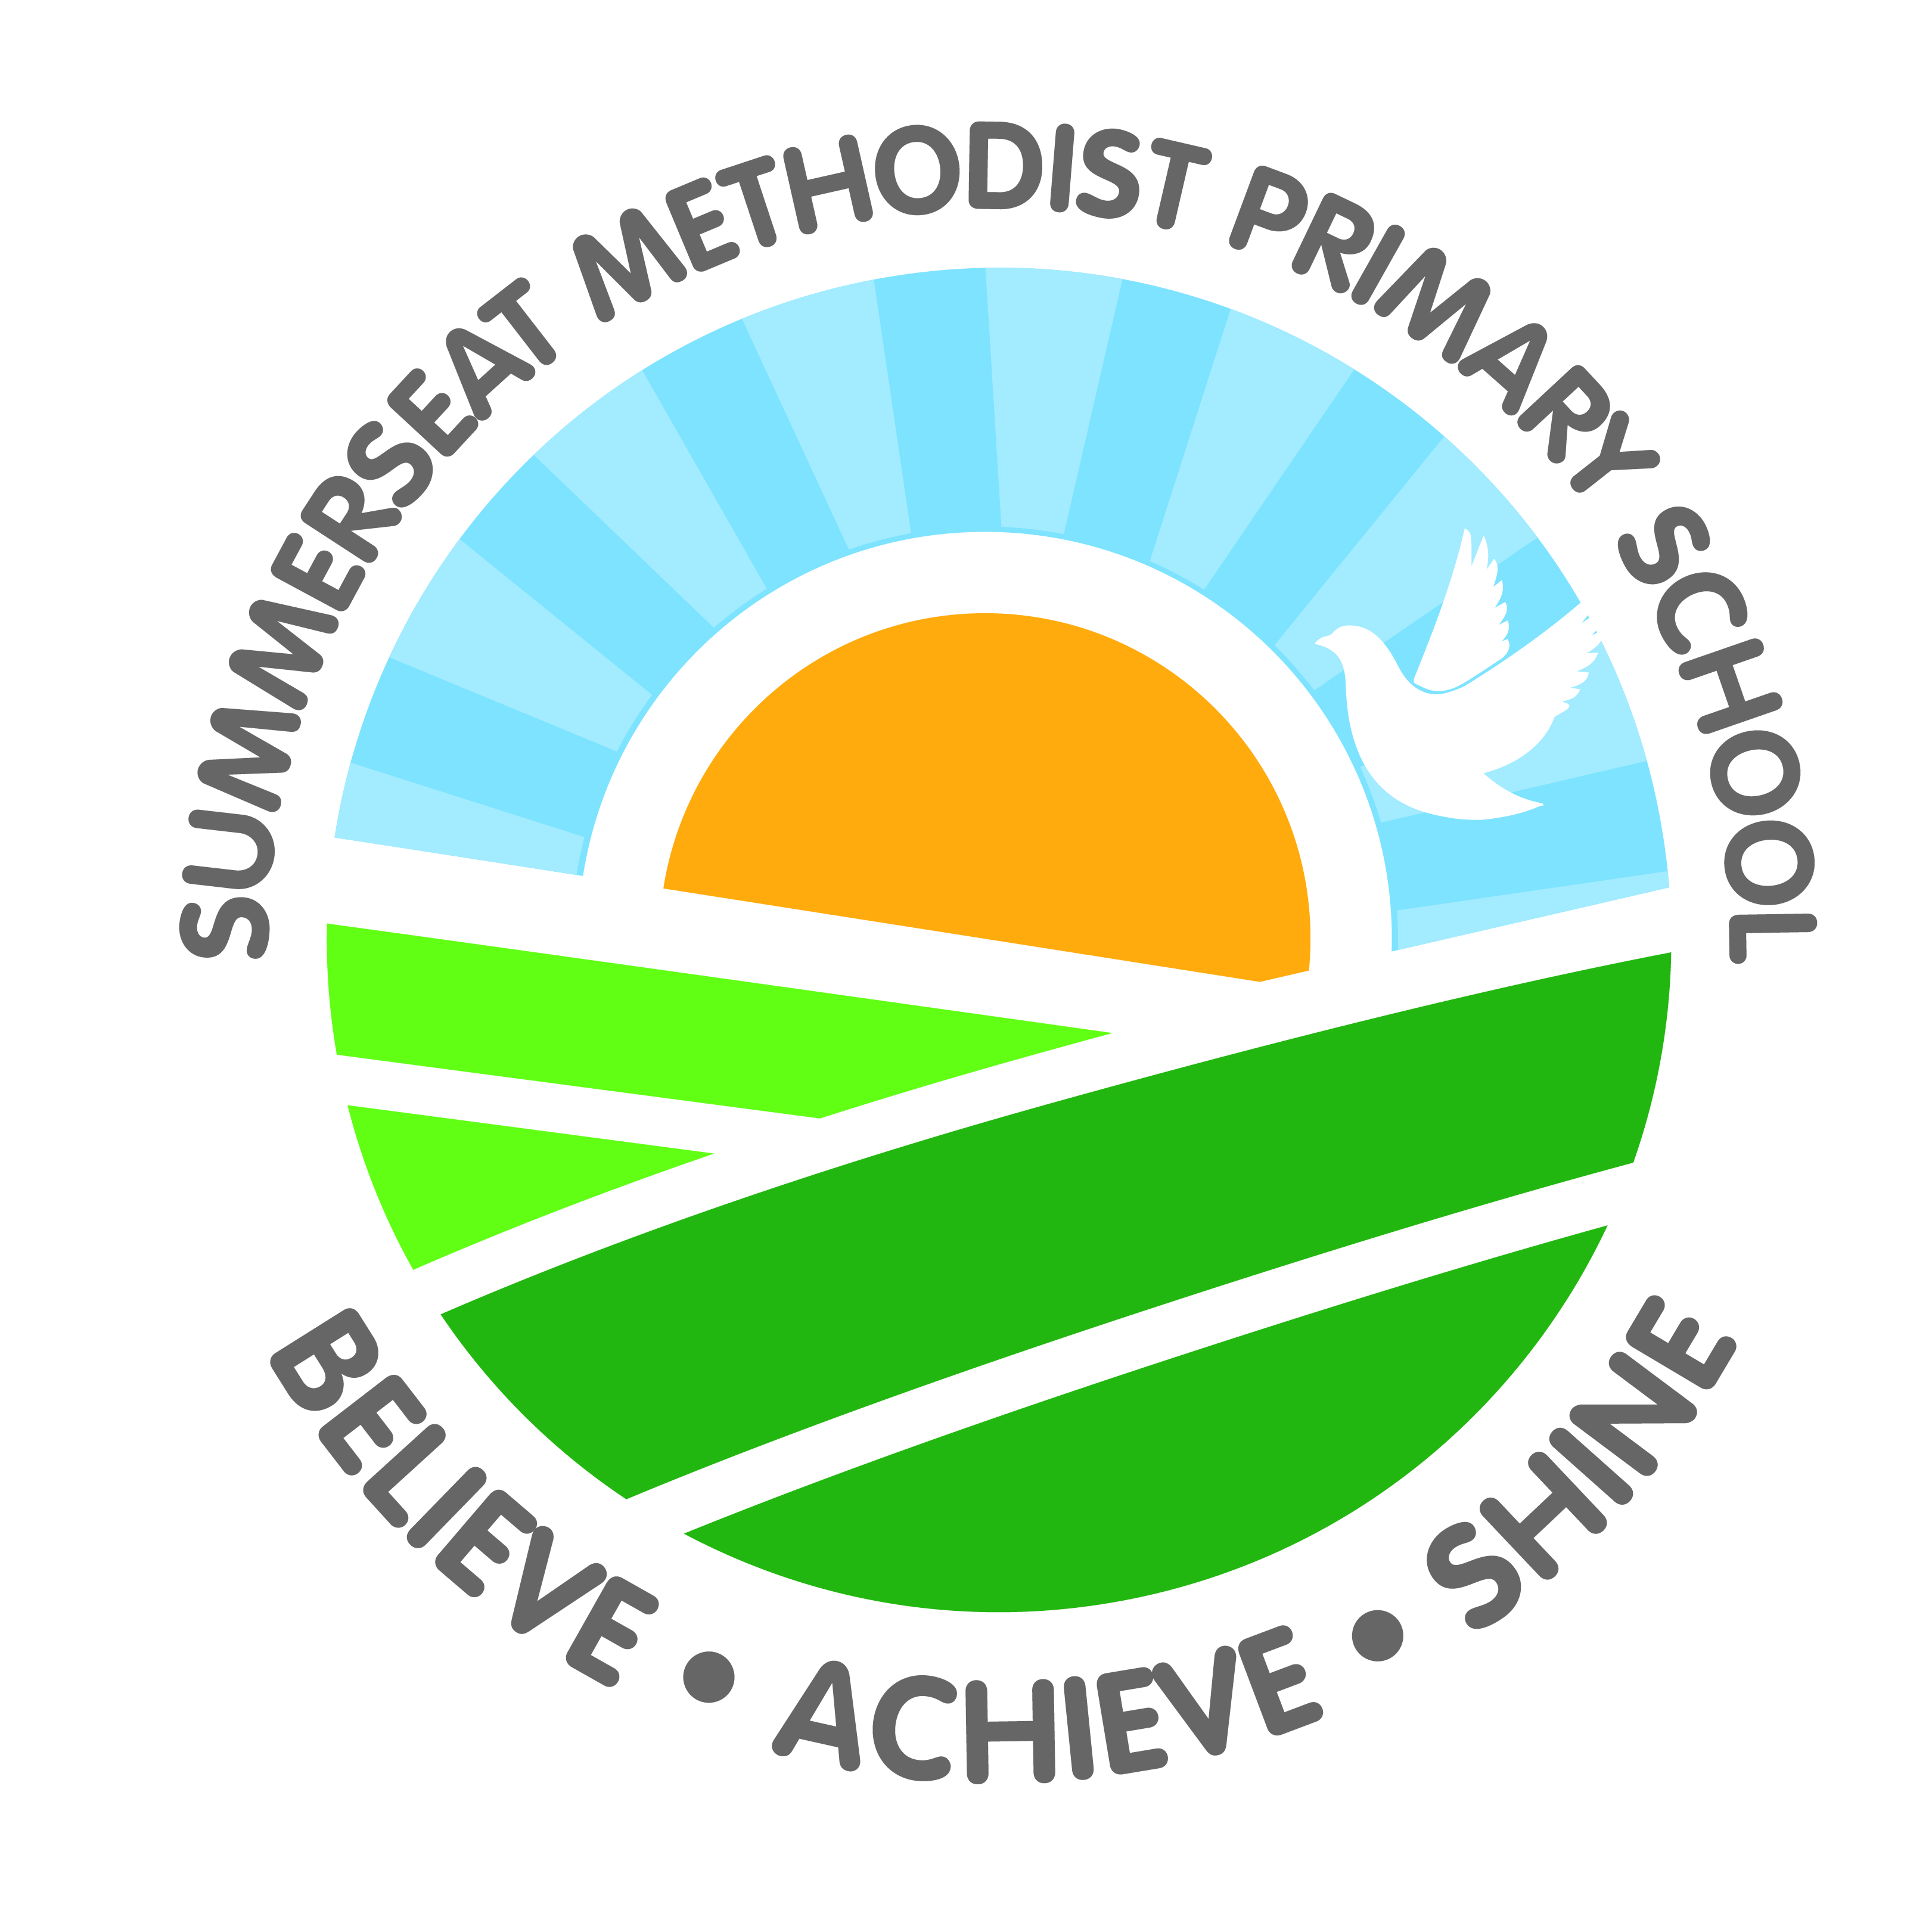

French Whole School Long Term Overview

Year Group | A1 | A2 | Sp1 | Sp2 | Su1 | Su2
Class One | Greeting each other (Core 1)  Vocabulary:  Bonjour! Hello!  Au revoir! Goodbye!  Salut! Hi!  Bonsoir! Good evening!  À bientôt! See you soon! | Introducing Themselves (Core 1)  Question and Answer:  Comment tu t'appelles?  What is your name?  Je m'appelle...  My name is... | How are you?  (Core 1)  Vocabulary:  très bien very well  bien well  comme ci, comme ça so-so  mal not well  merci thanks  et toi? and you?  Question and Answer:  Ça va? How are you?  Ça va… I’m… |  | Counting up to 10  (Core 1)  Vocabulary:  un one  deux two  trois three  quatre four  cinq five  six six  sept seven  huit eight  neuf nine  dix ten | Counting up to 10  (Core 1)  Question and Answer:  Quel âge as-tu?  How old are you?  J'ai … ans. I’m … years old.
Class Two  Block A | Expressing Likes and Dislikes  (Core 2)  Vocabulary:  j'aime... I like…  je n'aime pas… I don’t like…  oui yes  non no  le chocolat the chocolate  la musique the music  les biscuits (m) the biscuits  le tennis tennis  Question and Answer:  Tu aimes…?  Do you like…?  Oui, j'aime…  Yes, I like...  Non, je n'aime pas…  No, I don’t like… |  | Naming Colours (Core 2)  Vocabulary:  rouge  red  vert  green  blanc  white  bleu  blue  jaun  yellow  noirblack  rose  pink  violet purple  orange orange  Question and Answer:  C'est de quelle couleur?  What colour is it?  C'est… It’s… | Counting 11-20 (Core 2)  Vocabulary:  onze eleven  douze twelve  treize thirteen  quatorze fourteen  quinze fifteen  seize sixteen  dix-sept seventeen  dix-huit eighteen  dix-neuf nineteen  vingt twenty  Question and Answer:  Il y a combien de biscuits?  How many biscuits are there?  Il y a…biscuits.  There are…biscuits. | Saying the Days of the Week (Core 2)  Vocabulary:  lundi Monday  mardi Tuesday  mercredi Wednesday  jeudi Thursday  vendredi Friday  samedi Saturday  dimanche Sunday  danser to dance  Question and Answer:  On est quel jour?  What day is it?  On est…  It is…
Class Two  Block B | Identifying body parts  (Core 3)  Vocabulary:  la tête the head  les épaules (f) the shoulders  les genoux (m)the knees  les pieds (m) the feet  le nez the nose  les yeux (m) the eyes  les oreilles (f) the ears  la bouche the mouth  Question and Answer:  Qu'est-ce que c'est?  What is it?  C'est… / Ce sont…  It’s… / They’re… | Identifying body parts (Core 3)  Vocabulary:  le bras the arm  la jambe the leg  la tête the head  le pied the foot  le ventre the stomach  le dos the back  le genou the knee  l'épaule (f) the shoulder  la main the hand  le doigt the finger  Question and Answer:  Comment est mon monstre? What’s my monster like?  Il a… He has… | Counting 11-20 (Core 2)  Vocabulary:  onze eleven  douze twelve  treize thirteen  quatorze fourteen  quinze fifteen  seize sixteen  dix-sept seventeen  dix-huit eighteen  dix-neuf nineteen  vingt twenty  Question and Answer:  Il y a combien de biscuits?  How many biscuits are there?  Il y a…biscuits.  There are…biscuits. | Introducing their immediate family  (Core 1)  Vocabulary:  ma mère my mother  mon père my father  ma sœur my sister  mon frèr e my brother  ma grand-mère my grandmother  mon grand-père my grandfather  Question and Answer:  C'est qui? Who is it?  Voici…. Here is... | Naming the months of the year (Core 3)  Vocabulary:  janvier  January  février  February  mars  March  avril  April  mai May  juin June  juillet July  août August  septembre September  octobre October  novembre November  décembre December | Talking about birthdays  (Core 3)  Question and Answer:  C’est quand, ton anniversaire?  When is your birthday?  Mon anniversaire est en...  My birthday is in...
Class Three  Block A | Core 1  - Greeting each other  - Introducing themselves  - Counting up to 31  - Introducing their immediate family | Animals  - Saying animal vocabulary  - Asking about pets  - Describing animals using adjectives  - Using prepositions  Naming animal homes | Food  - Naming common foods  - Expressing likes and dislikes  - Saying what they are eating  - Naming cutlery  - Saying what they would like to have  - Understanding cooking instructions | Playtime  - Basic commands (imperatives)  - Saying what’s in the playground  - How to say a variety of playground games  - Using “j’aime” with another verb  - Saying what and where they like to play | Core 2  - Saying the days of the week  - Naming colours  - Counting up to 31  - Naming countries  - Expressing likes and dislikes | At School  - Saying how they travel to school  - Naming places in school  - Listing the contents of their pencil case  - Telling the time  - Naming school subjects
Class Three  Block B | My Home  - Saying where they live  - Identifying a variety of rooms and types of furniture  - Saying what there is in the kitchen  - Describing their daily routine | My Town  - Asking how much something costs and saying prices  - Talking about what is in their town  - Giving directions  - Saying names of shops  - Saying the names of items you might buy in a shop | Core 3  - Identifying body parts  - Counting up to 31  - Identifying items of clothing  - Naming the months of the year  - Talking about birthdays | People  - Saying colours that are useful for describing hair and eyes  - Describing physical features  - Describing a person’s personality  - Saying what they are wearing  - Using “il” and “elle” with “être” and “avoir” | The Body  - Naming parts of the face  - Saying basic verbs in the first person  - Saying that something hurts  - Naming fairy tale characters  - Saying traditional fairy tale locations | Sport  - Talking about the sports they play  - Expressing likes  - Detailed vocabulary for football and tennis matches  - The use of the verb “savoir”
Class Four  Block A | On Holiday  - More countries  - Holiday accommodation  - Vocabulary associated with the zoo, beach and theme park  - Using the perfect past tense | Eating Out  - Asking for items in a shop or restaurant  - Asking how much things cost  - Some basic weights  - How to order for others in a restaurant | Hobbies  - Naming hobbies  - Talking about types of music and giving a variety of opinions  - Saying what musical instruments they play  - Talking about different types of film | School Trip  - The perfect past tense  - The future tense  - Some common verbs  - Vocabulary associated with a trip to a museum and the countryside. | Seasons  - The names of seasons  - Talking about seasonal activities  - Saying the date and when their birthday is  - Naming craft materials  - Following craft instructions | The Future  - The future tense in the first, second and third person singular and first person plural  - Using adjectives to compare people  - More ways to describe how they are feeling
Class Four  Block B | Actions  - Using action verbs in the first person  - Using action verbs in the third person singular  - Using some adverbs  - Naming craft materials  - Using the perfect past tense in the third person singular form | Jobs  - Naming a number of jobs in French  - Saying what they want to be when they’re older  - Naming some workplaces  - Saying vocabulary linked to space stations and fire stations | In France  - Learning where some French cities are located in France  - Talking about tourist attractions in Paris  - Learning about French-speaking countries  - Naming popular French foods | The Environment  - Saying what the weather is like  - Naming garden creatures  - Talking about garden activities  - Talking about recycling | Family  - Naming extended family members  - Saying how many siblings they have  - Talking about the household tasks they do and have done  - Forming sentences using “on”  - Vocabulary associated with birthday parties | A Weekend With Friends  - Talking about activities that they might do at the weekend  - Expressing what they would and wouldn’t like to do  - Asking others if they would like to do something  - Naming foods associated with midnight feasts  - Giving a reason for accepting or declining an invitation

